Understanding the life course and actions for better life outcomes for New Zealand’s children and youth

Children don’t exist in a vacuum – we all create the environment in which they live. We know that it takes all of us to support our children to have healthy bodies and brains, to learn and develop, to belong to their culture and community and be valued.
The Department of the Prime Minister and Cabinet would like to hear your views on what needs to happen to enhance the wellbeing of children and young people in New Zealand. Working with a range of other government agencies, the Department has developed a series of domains that describe various aspects of wellbeing (you have this as a separate attachment). This is the starting point for our discussion in the hui – what do you think needs to happen if we are to give our children the best chance of great life outcomes?
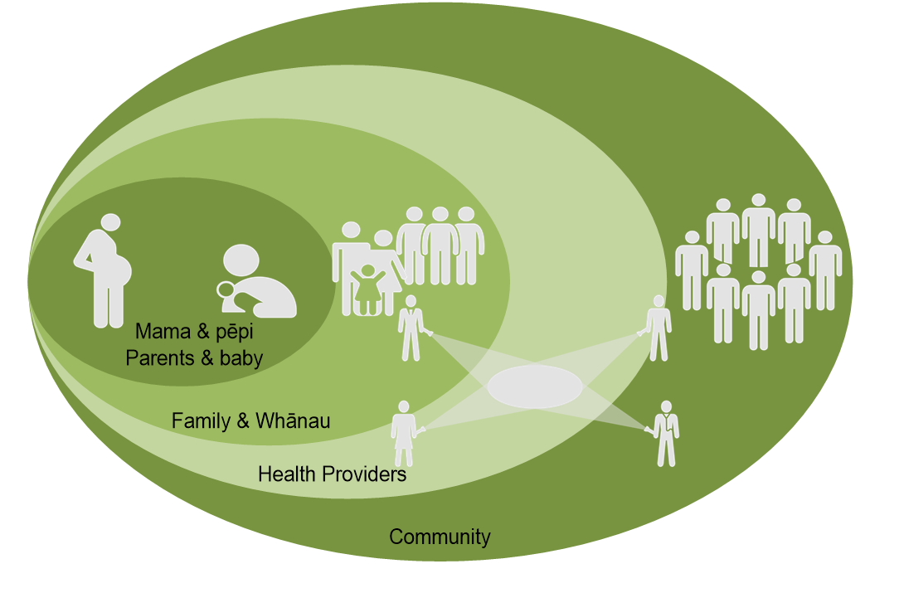
As health providers we have the privilege of interacting with all people, literally from life to death. That means that we have a unique opportunity to support children, young people and their whānau. That’s why the Department of the Prime Minister and Cabinet is wanting to hear from us about what we think matters.

Here are brief summaries of four key papers to get you thinking even more about what we might do to make New Zealand the best place in the world for children and young people… have a read before the hui and come prepared to say what you think matters for our children and young people…

Childhood Well-being: What it looks like, how it can be undermined, and how to promote it. (Office of the Prime Minister’s Chief Science Advisor)
Profs Richie Poulton, Sir Peter Gluckman, John Potter, Stuart McNaughton and Ian Lambie

The Government’s Science Advisors have written a paper that summarises the science about wellbeing for children and youth. The paper has been used to inform Cabinet papers and decisions.
In summary, the paper notes that:
- well-being is a broad concept that has its roots in early life
- research, particularly neuro-science, has highlighted the critical role played by early brain development for subsequent well-being, as measured across multiple domains
- the young brain is especially sensitive to environmental inputs both positive and negative
- the empirically supported starting point for protecting and promoting well-being is a programme of joined up (across both service sectors and life stages) evidence based interventions, beginning at conception through to the early twenties and delivered according to proportionate universalism principles
- an ethos of continuous improvement in service content and delivery is the other key ingredient for improving well-being, which will require sophisticated data collection, analysis and interpretation
- if these things are done well, appreciable gains in wellbeing can be expected with benefits persisting and possibly strengthening over time
The detail in the paper describes wellbeing, and outlines the key characteristics of children with high and poor standards of wellbeing. The authors explain the protective factors for good wellbeing and risk factors for poor wellbeing, pointing out the high co-occurrence of risk factors. The evidence supporting implementation is then discussed, with suggested policy considerations.
The paper frames wellbeing as a broad concept that describes a positive state of being. Five features of children with high wellbeing are identified:
- good physical and mental health;
- intact and well-functioning language and cognition;
- an age-appropriate social-emotional skill-set,
- friendships and social connection; and
- a robust cultural/self-identity.
The authors note that a supportive family environment and living in a safe and healthy community are also important contextual factors. Children don’t exist in a vacuum – we all create the environment in which they live, so parents, whānau and community matter. The paper says that the factors that enable positive wellbeing have been extensively studied. We know what matters, and it is a lack of application of this knowledge in policy design and implementation – rather than a lack of knowledge itself – that is the problem.
The paper states that in addition to knowing what good looks like, we also know what gets in the way of good life outcomes. “Poor wellbeing is synonymous with a failure to thrive physically, emotionally and socially.”
There are multiple risk factors for poor wellbeing, including:
- poor maternal health and well-being before, during and after pregnancy;
- poor parenting practices;
- childhood neglect and maltreatment;
- chaotic familial milieu often characterised by violence;
- mental health problems and substance abuse in key adults;
- a lack of friends;
- relational difficulties leading to rejection and/or victimisation;
- poverty;
- benefit dependency and lack of employment opportunities;
- poor educational achievement;
- low self-control and antisocial behavioural patterns;
- chronic physical and mental health problems;
- inequitable access to a range of government services.

The paper says that both positive and adverse experiences early in life can magnify and accumulate across the life-course. Or, as the Center on the Developing Child at Harvard University said in 2010 -“Some have compared a child’s evolving health and development status in the early years to the launching of a rocket, as small disruptions that occur shortly after take-off can have very large effects on its ultimate trajectory.”
Because of this, early brain development is critical to future wellbeing. The paper acknowledges a growing consensus that two key times for intervention are pregnancy through the first five years of life, and the adolescent years.
Finally, the authors contend that no one particular type of intervention has been shown to be superior. On the contrary, they say that evidence supports the use of a range of interventions, from conception through to the end of adolescence, to protect and promote wellbeing. However because individual interventions have small impacts, continuous service improvement should be the goal.
The paper recommends starting with the best programmes, adapting them for NZ (including Māori concepts on wellbeing), piloting these, and evaluating rigorously before full roll out. Programmes should also focus on the family/whānau as well as the child.

Early Childhood Position Statement

The Royal Australasian College of Physicians (RACP) has developed a position paper that summarises the actions they think are needed to promote better life outcomes by investing in children. It makes recommendations for both government and for commissioners and funders of health services. The paper is summarised below, along with the recommendations …

The RACP believes that a comprehensive, coordinated and long-term strategic approach to identifying and addressing disadvantage and vulnerability in children and infants should be considered by all tiers of governments to ensure that every child receives the best possible start in life.
Significant populations of children and young people in Australia and New Zealand are at risk of poorer developmental outcomes due to entrenched and often intergenerational disadvantage. However, there is strong evidence that investment in the early years of children’s health development and well-being is the most cost-effective means of tackling long term health conditions and health inequity. The RACP note that the antenatal period is included because of the unequivocal evidence about the influence of fetal wellbeing on the life-course.
This position statement describes the services and the physical, psychosocial and social environment required to promote optimum infant and child development in the period from conception and pregnancy through the preschool years, as indicated by current research and experience.
The RACP recommendations that concern the New Zealand government are:
- consider how best to integrate community Well Child Tamariki Ora services within a wider Primary Health Care model, as part of the review of the Well Child Tamariki Ora programme.
- work to reduce the long waiting times for developmental review, audiology and speech language therapy.
- paid parental leave policies should provide support for up to 6 months of paid parental leave to facilitate attachment and the establishment of breastfeeding.
- parental leave schemes need to be complemented by high-quality, accessible and affordable child care services.
- urgent updating of the New Zealand National Strategic Plan of Action for Breastfeeding, which expired in 2012.
- breastfeeding strategies and action plans need to be supported and implemented through multi-tiered early childhood programs starting in the antenatal period as well as the promotion of breastfeeding through community awareness, health sector and workplace policies and procedures
- further development and implementation of policies supporting healthy pre-school nutrition and activity programmes, and ensure that parents receive evidence informed advice about healthy nutrition for pre-school children as well as recommended sleep duration in children.
- implement a policy increasing the delivery and uptake of a minimum schedule of universal preventive child health, including links to the relevant maternity and immunisation registers and MBS items designed to be used at the time of immunisation.
- Continue the 20 hours per week Early Childhood Education (ECE) subsidy programme.
- National early literacy interventions should be developed involving a broad audience
- Health services for children and young people should continue to be provided at zero or low cost to all families
- Adequate, child focussed income support should be provided where there are dependent children of unemployed or disabled parents.
- Investigate the use of conditional and unconditional cash transfers such as cash incentives to pregnant women who quit smoking; and attendance at antenatal and postnatal health checks as a way of supporting and protecting child development, health and wellbeing.
- the safety of children must be a key factor in policy and legislative decisions, to prevent weakening legislation or regulation designed to protect children.
The RACP recommendations to commissioners and funders of health services are:
- health services working with primary caregivers and babies train staff in the promotion of infant caregiver attachment and early identification and referral of primary caregivers and infants when disordered attachment is suspected.
- there be a concerted effort to identify parental postnatal depression early and develop a sufficient well trained health services workforce to offer support and evidence based interventions.
- (new) parent support for the promotion of early child development should be provided as early as possible either as part of sustained nurse home visiting programs or centre based parenting programs.
- service providers endeavour to identify and ameliorate service level barriers in their specific context such as location and availability of appointments, outreach or childcare services for example.
- easy and timely access for vulnerable/poorly resourced families or those with ambivalent/poor engagement to referral to child development services, as well as primary and secondary paediatric mental health services.
- mental health, drug, alcohol and gambling addiction services prioritise services for parents with dependent children.

Rethinking New Zealand’s approach to mental health and mental disorder: A whole-of-government, whole-of-nation long-term commitment (Office of the Prime Minister’s Chief Science Advisor)
Profs John Potter, Richie Poulton, Sir Peter Gluckman, Stuart McNaughton and Ian Lambie
This paper has been publicly released, and the full paper is available in both a short and long form on www.pmcsa.org.nz
The authors describe this paper as “a mental health narrative providing a template upon which government can develop short- and long-term strategies to ensure that both the provision of services to those with mental disorder and the challenge of promoting mental wellness and resilience for us all in a rapidly changing world are addressed.” The paper outlines the current challenges in mental health in New Zealand, and considers what an effective response might look like. They have used this in their interactions with the Mental Health Inquiry, the findings of which is due to be released before Christmas 2018.
The paper starts by noting that every year, 1 in 5 New Zealanders experiences psychological distress or develops a mental disorder, but there is also a shortage of mental health services, and the services that do exist don’t work for everyone. The paper says that what is needed is a threefold approach, involving:
- working to reduce those stresses across the community;
- working to increase the psychological and emotional resilience of individuals, family, whānau, and community
- revitalising and upgrading therapeutic services so that they match the needs of those with mental disorder, both mild and more severe.
In addition, distinct strategies are required that a) focus on long term mental health resilience, especially mental health promotion from conception to early adulthood, and b) enhance early identification and treatment of mental disorders.
Social investment and life course approaches are highlighted as useful frameworks. In particular, early childhood is an important time for developing emotional and psychological resilience, and adolescents should be well supported in order to reduce suicidality and improve outcomes. The authors also advise that there is a special need to focus on Māori resilience and vulnerability.
Finally, the paper reminds readers that a long term view, over a generation or more, is required. However, some actions can begin immediately. These include strengthening the quality and competence of our early childhood education workforce, building resilience and self-control during the primary and intermediate school years, by extending and refining whole school programmes, ensuring that vulnerable children are better supported across the transition into secondary education, and better understanding the needs for mental-health resources in the justice sector.

NOTE : The Royal Australian and New Zealand College of Psychiatrists (RANZCP) has two position papers relating to children and young people, both of which contain recommendations.

‘The Prevention and Early Intervention of Mental Illness in Infants Children and Adolescents’
https://www.ranzcp.org/Files/Resources/College_Statements/Position_Statements/ps63-pdf.aspx ‘Children of Parents with Mental Illness’ https://www.ranzcp.org/Files/Resources/College_Statements/Position_Statements/PS-56-Children-of-parents-with-a-mental-illness-Ma.aspx
From Complexity to Collaboration: creating the NZ we want for ourselves and enabling future generations to do the same for themselves
Donna Provost (Office of the Children’s Commissioner) and Elizabeth Eppel and Girol Karacaoglu (School of Government at Victoria University)
We know that children don’t exist in a vacuum – parents, family, whānau and community create the environment in which children are conceived, born and grow up.
So how do we as a society need to change to support parents and children, and make New Zealand the best place in the world for children and young people? And what’s Government’s role in driving that change?
The authors of this academic paper describe it as a 'provocation for change' if we are to achieve ambitious goals like reducing child poverty and improving child wellbeing. The key points are summarised below…
The paper notes that while the ultimate objective of Government policy and action is to improve people's lives and wellbeing now and into the future. But traditional policies are clearly failing to generate the changes we need to address persistent and increasing disadvantage.
The paper looks at the implications of complex social issues, and what that means for design and implementation of policies and services. It then provides a concise summary of past efforts to solve complex problems, noting their common design elements and what we might learn from them, including community led development; cluster based social and economic development; collective impact; and central government led initiatives (including whānau ora, social sector trials and place based initiatives).
The writers identify six principles they suggest need to be at the core of designing and implementing public policy for complex issues such as child wellbeing:
- broad agreement on the trajectory of change and the desired outcome (agreeing on what good looks like)
- the necessity of collaboration (government alone doesn't hold all the levers)
- the need for continual communication and trusted working relationships, with adaptive leadership at every level (necessary to talk and listen to ensure everyone is working to the same goals)
- being aware there is no 'one solution' (e.g. shotgun rather than a silver bullet, with a sound theory of how each initiative will contribute to better child wellbeing)
- agreement on the measures of change (shared understanding of what success will look like and how we will measure our progress towards achieving it)
- the courage to be persistent - continuing to focus on the goal, not the means, as complex problems will continue to change.
The paper states that government needs to rethink its role to become more of a system steward, rather than directing or engineering specific outcomes. This means implementing policies that provide frameworks and allow adaptation by communities to develop what works for them. It challenges us to create conditions of trust, and consider how we enable local communities to be more transformative for children, their families and whānau, and the wider population. It notes that the time is ripe for advancing our thinking and actions to make a difference.

