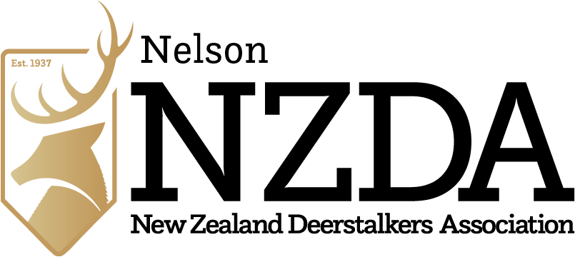
AHT Trophy Competition Entry Form 2024

Name, Signature & Date:……………………………………………………………………………………
Membership number and email contact:…………………………………………………………………..
Use table below to select category – a separate form is required for each entry
Code | Trophy | Category | Tick
A | Sports Depot Cup | Best Chamois
B | Bob Baigent Cup | Best trophy by a junior (under 18 years age)
C | Bob Baigent Trophy | Horned Game excluding Chamois
D | Whitcombe Challenge Trophy | Best NZ Deer
E | People’s Store Trophy | Best Nelson Deer
F | Williams Cup | Best Pig Tusks
G | Rakiura Cup | Best Whitetail
H | Shuttleworth Trophy | Best Red Deer
Note:
- The Eddy Trophy will be awarded on Douglas score Conversion from all categories with all entries automatically eligible
- The Women’s Trophy is the same criteria as above but for female entries
- Entries to have been taken in period since the last event (25th July, 2023)
- By signing you are accepting the rules and requirements further below
Details of trophy:
Date taken……………………….

Locality………………………………………………………………………………………………………

Brief account of stalk and taking of the trophy………………………………………………..………………………………………………………..
…………………………………………………………………………………………………………………
…………………………………………………………………………………………………………………
For Branch Use:
Douglas Score: ……………………. Measured By: ………………………………………………………
Assisted by: ………………………………………………………………………………………………….

Trophy Competition Rules are based on the National Rules National-Competition-Rules-2020.pdf and Ethics
Rules:
All Trophies will be taken by fully financial (i.e. paid up) members and in accordance with National rules of Ethics and Fair Chase NZDA Ethics and Fair Chase Rules

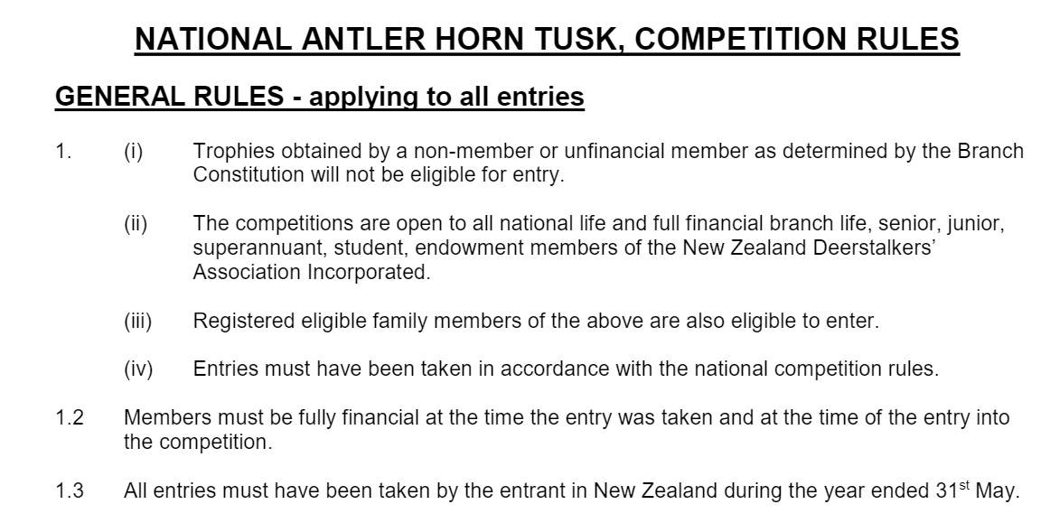
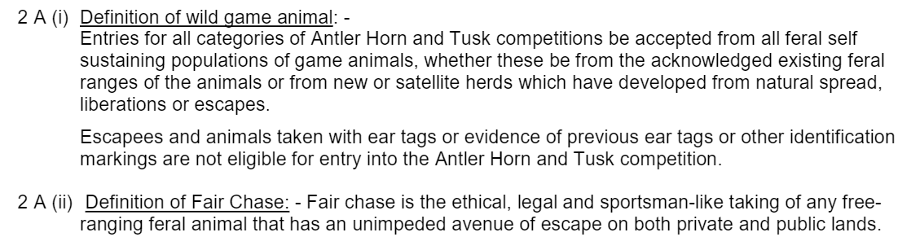
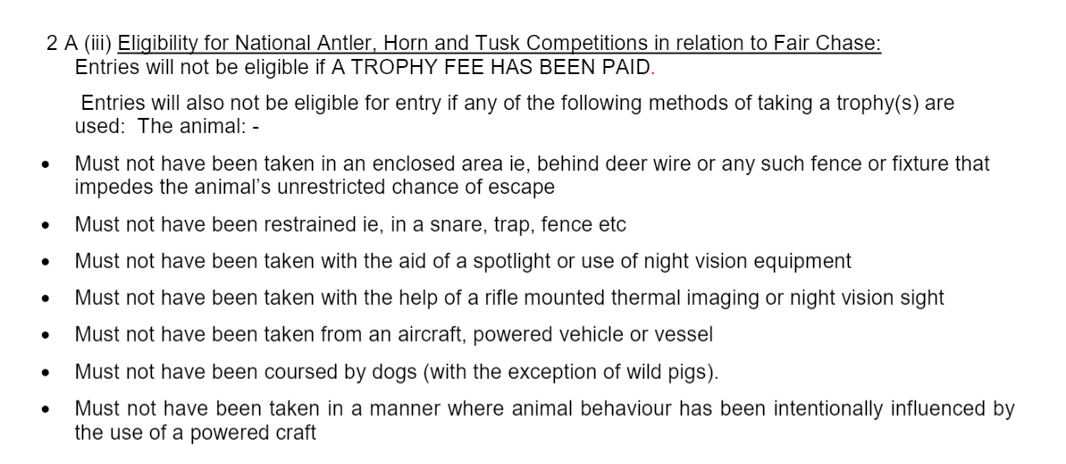
Requirements:
- Trophies need to be well cleaned and fit to be presented
- Late entries may not be accepted

