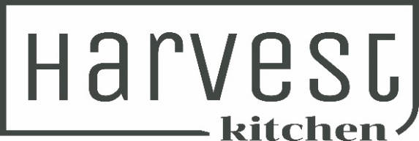
Winter Menu

Light Bites
Crispy 5 Spice Pork & Ginger Wontons with Homemade Chilli Sauce 15

Chefs House Made Dips with Toasted Artisan Bread 17
Harvest Hummus, Vegan Basil Pesto & Chef’s Choice Dip

Warm Ciabatta Loaf Bread filled with Garlic Butter 15
Enough for 2

Chicken Liver Pate, Truffle Butter, Pinot Noir Jelly, Blueberry Chutney & Toasted Crostini
(GF Bread available on Request) 26

Main Meals
Homemade Roast Vegetable Lasagna with Pesto Oil, Salad Greens & Toasted Seeds 30
(Vegetarian) (GF) (DF)

Smoked Chicken Caesar Salad, Cos Lettuce, Crispy Bacon, Parmesan Cheese, Croutons, Soft Boiled Egg & Creamy Caesar Dressing (GF option – NO croutons on Request) 30

Creamy Smoked Fish & Mussel Chowder with Ciabatta Bread & Butter 28
Crunchy Karaage Chicken Burger, Crispy Fried Chicken, Asian Slaw, Soy Ginger Mayo, Sesame Brioche Bun with Fries 30 (Karaage Tofu Burger available on request)

Twice Cooked Pork Belly, Fried Agrias, Apple Sauce, Red Wine Jus; Fennel & Apple Salad with Candied Walnuts (GF) (DF) (Contains Nuts) 35
Our Harvest Restaurant Signature dish – Perfect with Seifried Chardonnay

Ribeye Steak, Roast Field Mushrooms, Garlic Butter, Jus, Crispy Agrias; Spinach & Parmesan Salad with Balsamic Dressing & Toasted Seeds (GF) 36

Greenshell Mussels in a Creamy Red Curry Coconut Sauce with Toasted Ciabatta (GF Bread on request) (DF) 30
Harvest Big Breakfast, Streaky Bacon, Sausage Press Pork & Herb Sausage, Field Mushrooms, Potato Hash Cakes, 2 Fried Eggs, Toast & Harvest Kitchen Smokey Tomato Sauce (no changes possible) 29
Ploughman’s Platter for 2
Little River Cheese Selection
Moutere Sausage Press Salami
Marinated Olives
Gherkins & Pickled Onions
Chicken Liver Pate
Harvest Dips
Hot Smoked Salmon
Artisan Breads
56

SIDES/EXTRAS
Fries with Harvest Smokey Tomato Sauce 12
Kumara Fries with Spice Salt & Sour Cream 15
Side of Slaw/Side Salad 12
Gluten Free Bread 3
Extra Crostini 3
Extra Platter Bread 6
Extra Sauces 3

If you have a serious food allergy, please advise the team when you are ordering.
As we have Gluten, Wheat & Dairy in our kitchen we cannot 100% guarantee our meals are free of these items.

