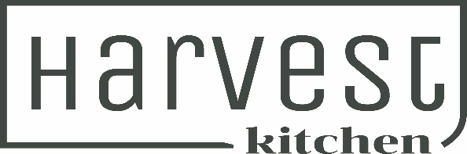
Autumn Menu 2024

House Made Dips with Toasted Artisan Bread 17
Hummus, Vegan Basil Pesto & Chef’s Choice
Great for sharing

Warm Ciabatta Loaf Bread filled with Garlic Butter 15
Enough for 2

Chicken Liver Pate with Seifried Rose Jelly, Gherkins, Pickled Onions & Toasted Crostini
(GF Bread available on Request) 28

Harvest All Day Breakfast, Streaky Bacon, Sausage Press Pork & Herb Sausage, Field Mushrooms, Tomato, Potato Hash, Fried Eggs, Toast & Harvest Kitchen Smokey Tomato Sauce (no changes possible) 30

Creamy Smoked Fish & Mussel Chowder with Ciabatta Bread & Butter 28
Greenshell Mussels in a Garlic, Riesling & Lemon Butter Sauce with Toasted Ciabatta (GF on request) 30
Harissa Roast Eggplant with Chickpea, Roast Red Onion, Cucumber, Spinach Salad, Pomegranate Dressing & Preserved Lemon Labneh (Vegetarian) (vegan without labneh) 29

Smoked Chicken Caesar Salad, Cos Lettuce, Crispy Bacon, Parmesan Cheese, Croutons, Soft Boiled Egg & Creamy Caesar Dressing (GF option – NO croutons on Request) 30

Crunchy Karaage Chicken Burger, Crispy Fried Chicken, Asian Slaw, Soy Ginger Mayo, Sesame Brioche Bun with Fries & Harvest Tomato Sauce 30 (Karaage Tofu Burger available on request)

Twice Cooked Pork Belly, Crispy Fried Agrias, Apple sauce, Jus & Waldorf Salad (GF) (DF) 35
Our Harvest Restaurant Signature dish – Perfect with Seifried Chardonnay

Ribeye Steak, Roast Field Mushrooms, Garlic Butter, Jus, Crispy Agrias & Spinach,
Tomato & Parmesan Salad (GF)(DF) 36
SIDES/EXTRAS
Fries with Harvest Smokey Tomato Sauce 12
Kumara Fries with Spice Salt & Sour Cream 15
Side of Slaw/Side Salad 12
Gluten Free Bread 3
Extra Crostini 3
Extra Platter Bread 6
Extra Sauces 3

Ploughman’s Platter for 2
Little River Cheese Selection
Moutere Sausage Press Salami
Marinated Olives
Gherkins & Pickled Onions
Chicken Liver Pate
Harvest Dips
Hot Smoked Salmon
Artisan Breads
56
If you have a serious food allergy, please advise the team when you are ordering.
Many of our dishes are gluten free and others can be altered to suit dietary needs.

