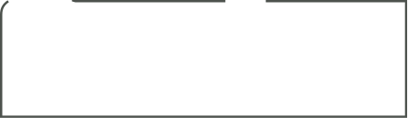

Seifried Nelson Pinot Noir   
Seifried Nelson Syrah

Aotea Reserve Sauvignon Blanc

Seifried Nelson Sauvignon Blanc

Seifried Nelson Pinot Gris

Seifried Nelson Chardonnay

Seifried Nelson Rosé

Seifried Nelson Riesling

RED

WHITEE

*ALL Seifried Wines by the Glass* **$12**

*Seifried Wines by the Bottle* **$48**

*Aotea Reserve Sauvignon Blanc Glass***$14**

*Aotea Reserve Sauvignon Blanc Bottle* **$56**

BY THE BOTTLE ONLY ONLY ONLYONLY

Seifried Merlot **$48**

Seifried Gewurztraminer **48**

Aotea by the Seifried Family Nelson Méthode Traditionnelle **$56**

Winemakers Collection Sweet Agnes Riesling 375ml **$60**

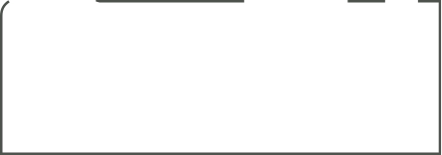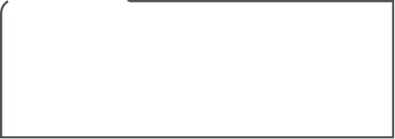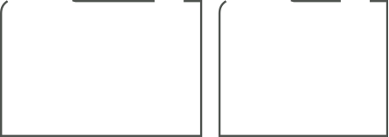

CIDER

**Please note: We do not have an off licence. Unfinished Bottles of wine may not be taken home**

Hop Federation Craft Beer Brewed in Riwaka

Glass **$10**

Pint **$14**

Hop Federation Stout 440ml Can **$14**

**ON TAP** Pilsner, Lager & Hazy IPA

BOTTLED BEER

TAP BEER

NON-ALCOHOLIC

**Juice Selection – All $5**  
*Orange, Apple, Pineapple or Tomato*

Feijoa & Apple *-* Chia Sisters *-* **$6**

Blackcurrant Crush -Pete’s Naturals- **$6**

Pangatotara Organic Pear Juice - **$6**

Sparkling Water – 300ml **$6**

Iced Coffee **$8.50**

IcedChocolate **$8.50**

**Sodas - $5**

Coke

Coke - No Sugar

Lemonade  
Raspberry & Coke

Lime & Soda

Ginger Beer - **$6**

Diet Ginger Beer - **$6**  
Lemon Lime & Bitters - **$6**

Seifried Rabbit Island Grape Juice **$7**

Capital Cider Co - Made in Brightwater, Nelson

**Love & Money** – Mixed Berry

**Winning** - Kaffir Lime, Lemon & Juniper

**Easy Rider** – Classic Apple

**All 440ml Cans**

SPIRITS

**$13**

**$13**

Heineken

Steinlager

Corona

Steinlager Light Beer

Heineken 0% - No Alcohol Beer

**$9**

Gin, Rum, Whiskey, Vodka, Bourbon, Canadian Club, Baileys, Apple Brandy, Kahlua

30ml Double shot with your choice of mixer - **$13**