Issue no. 120 / Autumn 2023
TRIBUTE TO JIM MUTCH
USING PODCASTS TO GREAT EFFECT – AN UPCOMING WEBINAR
FOUR DECADES OF PROFESSIONAL FUNDRAISING IN NEW ZEALAND
THE VALUE OF MENTORS
6
35

38
46

Fundraising Institute of New Zealand
Matatika Ma¯ tauranga Kaitautoko

Better and more cost-effective DM and Fundraising Services for FINZ members
ROE Print Services are specialists in not-for-profit direct mail and can support you to develop and execute successful campaigns that cut through a crowded market. With our specialist knowledge and industry relationships, we handle your campaigns from end-to-end, meaning you don’t have to worry about the process.

We provide:
- Campaign strategy planning
- Content and segmentation direction and development to increase giving levels
- Complete campaign management
- Access to bespoke handwritten fonts approved by NZ Post for use on outer envelopes
- Envelope bulk storage which reduces unit costs
- Utilisation of state-of-the-art high speed variable data presses meaning you only print what you need
- Access to a team with over 30-years collective experience in the not-for-profit direct mail sector
We can also support your wider fundraising and communications needs with our knowledge in strategy development and implementation of the major donor, bequest, regular and individual giving, trust and grant and corporate streams. Talk to us today about we can help your organisation to achieve its fundraising goals.

For FINZ Member discounts with ROE PRINT contact:
Grant Chellew
021 362 068
grant@chellew.co.nz

Peter Clarke
021 224 5058
peter@roeprintservices.co.nz

Kylie Malin
027 420 5337
kylie@roeprintservices.co.nz

2 | Official publication of the Fundraising Institute of New Zealand | www.finz.org.nz

CONTENTS

Commentary — Jim Datson & Gwen Green | 4 |  | Case Study – Salvation Army | 36
‘The Founding Father of Fundraising in |  |  | In memory of Tony Pilalis | 37
Four decades of fundraising leadership 38
Aotearoa NZ’ – James Thomas Mutch | 6
FINZ 2022 Award Winners and Finalists | 10

Farewell and thanks to departing CEO 40
Nonprofit Trends Report  FINZ Membership Matters | 19  22 |  | Create clarity for your charity by leaning into change | 42
An elegy to Admin costs | 23 |  | The sector is growing up | 44
Save the Children: Adapting to change in the digital space | 24 |  | FINZ Mentor Programme | 46
Two new Fellows appointed at the 2022 FINZ conference | 26
CFRE – “You wouldn’t cancel on yourself” | 28
Advocacy update | 31
Giving Architects | 32
Are you ready to launch a podcast as part of your fundraising/marcomms mix? | 35

COVER: Jim Mutch trying out his new, 6 months old titanium hip at Snowmass, CO in March 2017. The rest of him is 88 years old.

www.finz.org.nz | Official publication of the Fundraising Institute of New Zealand | 3

AUTUMN 2023 NUMBER 120
PUBLICATION INFORMATION
FINZ magazine is published by the Fundraising Institute of New Zealand (FINZ)

04 499 6223
0508 64 FINZ (0508 64 3469)
info@finz.org.nz www.finz.org.nz

EDITORIAL
info@finz.org.nz GRAPHIC DESIGN

JIM DATSON
Co-Chair

GWEN GREEN
Co-chair

Angela Christmas 021 362 065
a.christmas@xtra.co.nz PRINT SPONSORED BY

With the working year of 2023 well underway, we hope that 2023 is a successful one - for you individually, organisationally and for the wider sector. The importance of the work of our sector continually increases and with that, the vital necessity of successful fundraising.

POLICY STATEMENT
The policy of FINZ Magazine is to provide a channel of communication between those involved in fundraising and a place where
debate and exchange of views
may take place. We report on the broadening parameters of fundraising practice and publish information related to the community and charity sector.
Original articles of interest to people wholly or partly engaged in the raising of funds
for the community sector are welcome, as are letters to the editor, comment and information.
The opinions and views expressed in this magazine should not be taken to represent the official opinion of
the Fundraising Institute of New Zealand.
Free to FINZ Members ISSN 11799722
The significance of our Institute as the keeper of standards
of ethic and professional practice also continues to grow. Competition for funds never abates and the temptation (some would say need) to cut corners or cross the line of honest, transparent portrayal
of fundraising behaviour on one hand and organisational use of funds on the other necessitates the existence of strong codes. More than anything of course, strong codes protect you and your organisation as much as the supporting public. For that reason alone, all organisations raising funds should be and are encouraged to be members of FINZ.
As we celebrate 40 years of the existence of a Fundraising Institute in Aotearoa New Zealand, it is an opportunity to look back at how the sector in general and fundraising
in particular has developed over those years. The total value of fundraising revenue generated back in 1983 is not known. But, we do know that it likely exceeded the
$1bn mark in the early 2000s. By the time the Charities register was established it could be confirmed that total fundraising revenue across the sector had exceeded
$2bn by 2010 before sky-rocketing above $5bn annually from 2018.
That is a staggering level of public generosity, representing the equivalent of $1,000 per head of population from individual, business and grant-making sources.
Much of the growth can be attributed to the professionalisation of training and education that has become available. It is a primary reason why FINZ has invested so much over the years in education and promotion of professionalism.
We plan this year to continue our investment in education,

peer networking and skill share opportunities. Much of this will only be available to Members.
In this edition of our magazine, we take opportunity to celebrate the growth and development
of fundraising in Aotearoa New Zealand with a lead article describing the establishment and early development of our Institute during its first decade.
We continue the theme with snippets from across the years, leading to celebration of the achievements of 2022 – our Changemakers conference and
annual awards for excellence.
We also acknowledge the importance and support we all have access to through our valued sponsors and have invited them to share articles and information relevant to you and your work we expect you will find helpful.
Finally, we both wish to acknowledge the voluntary contribution of all who participate at national, Regional and local levels in our Institute to bring you the activities and opportunities to share and learn – from our Mentors who give so generously of their
experience, to our Committee members and other volunteers who assist with projects and important events. We cannot
achieve what is needed or expected of our Institute without such willing talent and contribution. Thank
you. We look forward to providing additional opportunities for you to become more actively involved in strengthening both our Institute and sector.
Best wishes from us both for a successful 2023.

Need Help with your Fundraising? | - Funding Applications
Working with New Zealand charities, schools and sports organisations for over 25 years, Maitland and Associates has extensive fundraising knowledge and experience.  Whether it’s completing your fundraising activities, enhancing your current fundraising programme, and/or training/ mentoring existing staff, Maitland and Associates can make a positive difference. | - Direct Mail  - Fundraising Plans  - Gifts in Wills  - Donor Development
For a no obligation chat contact Stephanie Maitland CFRE FFINZ MFINZ Ph: (09) 626 0581 • Mob: 0274 866 711  stephanie@maitlandassociates.co.nz www.maitlandassociates.co.nz | - Fundraising Training Mentoring
 | - Special Events

This document is printed on Sumo Matt, an environmentally responsible paper, produced using Elemental Chlorine Free (ECF), Third Party certified pulp from Responsible Sources, and manufactured under the strict ISO14001 Environmental Management System.

www.finz.org.nz | Official publication of the Fundraising Institute of New Zealand | 5

With the 40th Anniversary of FINZ imminent, we Honour a Very Special New Zealander…

‘The Founding Father of Fundraising in Aotearoa NZ’

James Thomas Mutch was born on 22nd October 1928, in New Zealand.
After his schooldays Jim, as he is known, studied at Victoria
University then spent a few years in government service. But his restless energy and enterprise soon took him overseas to London where he ventured into international trading of metals and minerals before returning to Wellington to manage an import/export business.
Then, as a 30-year-old, Jim made a very significant and life-long change to his chosen career: he became a fundraising professional.
Always intent on learning from the best practitioners, Jim crossed the Tasman to Australia. There
he worked for the US-based Wells Charitable Fundraising Organisation. Diligently applying
himself to his ‘apprenticeship’ with typical dedication and discipline, in the following three years he raised more than A$1.8 million for 25 charities. This, by a ‘newbie’ in the early 1950s!
While in Australia Jim became the first New Zealand citizen to join what is now the AFP (Association of Fundraising Professionals,
USA). By travelling to the USA during this time, his membership gave him introductions to the best fundraising professionals
in the USA. Jim very quickly saw the considerable advantages of
formal gatherings of like-minded fundraising professionals learning and sharing innovation, knowledge and techniques.
This made a strong impression on Jim - a vision, even - of the benefits of collegiality that never left him.
Jim returned to Wellington and on 30 March 1961, he registered his own professional fundraising consultancy, Zealandia Associates
Ltd. This initiative took considerable courage and foresight on Jim’s part as professional fundraising was
still very much in its infancy in New Zealand.
He had some valuable help in the early stages of establishing his consultancy. Syd Heron, then the Managing- Director of Wells Organisation in Sydney, was not only a friend of Jim’s but also soon became a valued adviser and
mentor. Syd Heron was something of an icon in the fundraising profession. To this day, he is revered and recognised by the Fundraising Institute Australia by having their annual conference keynote ‘Oration’ named after him.
Jim’s consultancy’s early fundraising projects were mainly for churches. Two hundred parishes throughout the country benefited from repetitions of three-year pledge cycles that he developed and promoted. Other successful early campaigns raised funds for

Downstage Theatre (Wellington) and Nelson’s Theatre Royal.
However, Jim clearly missed the benefits of regularly associating with other fundraising professionals and became a member of the Brisbane Chapter of the (then) Australian Society of Fundraisers, occasionally crossing the Tasman to meet with them in person.
In 1982, after visiting Australia for a fundraising conference, Jim again went to the USA to study the charity and voluntary sector. There he met notable, successful fundraising professionals and, yet again, experienced the knowledge and insights that are to be gained by such exchanges internationally.
One of the‘notables’ Jim met on that visit was Hank Rosso who soon became his mentor and friend. This resulted in Jim inviting Hank to come to New Zealand to conduct his five-day Introduction to Fundraising courses. Hank ran a thriving fundraising consultancy in California and the courses Hank and Jim ran in New Zealand were the first to be held outside continental North America. Jim
assisted Hank both financially and personally with the visit.
Around this time Jim also authored two publications: in 1977 a 20-page booklet titled Basic

6 | Official publication of the Fundraising Institute of New Zealand | www.finz.org.nz

Principles in Fundraising; and in 1981, Fundraising and Development in the Voluntary Sector.
Jim’s two visits to the USA and the vision impressed upon him there, began to materialise when he wrote to the Administrator of what is now Philanthropy New Zealand:
“The visits opened my eyes to the potential for New Zealand to advance the effectiveness in so many fields. One of these fields was the cluster of Charitable Trusts which were acting independently of one another ……. My first priority was not to reform the practices of long-established charitable trusts but I did take every opportunity to point out to their trustees that they would increase their philanthropic effectiveness markedly by forming
an Association of Charitable Trusts.”
Jim’s subsequent lobbying of high-profile philanthropists resulted in the 1990 formation
of the New Zealand Association of Philanthropic Trusts, of which Jim was a founding member. In 2000 it was renamed Philanthropy New Zealand and still operates by that name today. In 2016 Jim was awarded Honorary Membership of Philanthropy New Zealand.
In 1982, with the workforce of the New Zealand professional fundraising sector increasing, Jim felt it was the right time to form a New Zealand Chapter of TAIF – The Australian Institute of
Fundraisers. Before that occurred Jim went to Australia and convinced the TAIF authorities to alter the word ‘Australian’ in their title, to ’Australasian’. They graciously acceded to his request and in September 1982 TAIF Chapter 6, New Zealand, was inaugurated.
It was the forerunner of FINZ (Fundraising Institute of New Zealand).
In the mid-1980s Jim convinced the Board of TAIF to hold their 1987 annual conference in Christchurch
– the first international fundraising conference in New Zealand. Jim chaired the conference committee. This successful event attracted 260 delegates - 200 from Australia.
Jim’s vision of over a couple of decades ago continued to taking shape…
The first President of TAIF Chapter 6, New Zealand, was one- time Labour MP for Invercargill (1972-1975), and a strong advocate for the disability sector, J B Munro, QSO JP. He held the office for three years and was succeeded by Jim Mutch for the subsequent three years, by which time the Chapter had over 100 members.
By 1990, Jim’s vision of nearly 30 years prior, finally became a reality.
New Zealand fundraising professionals amicably severed ties with their Australian counterparts and formally established an independent, national organisation of fundraising professionals The Fundraising Institute of New Zealand (FINZ).
Such a significant outcome is never the result of only one
person’s vision, initiative and years of work. Jim himself would be the first to acknowledge this. But Jim Mutch can take most of the credit for the establishment and initial development of TAIF Chapter
6, New Zealand, and then FINZ itself which quickly developed into a viable, ethical and reputable organisation for fundraising professionals in New Zealand; an organisation in which the New
Zealand donor-public can have full confidence.
Appropriately, in 1990, Jim was the first member of FINZ to be accorded the honour of being made a Fellow of the Institute.
Always willing to share his considerable expertise, Jim served a three-year term on the FINZ
Northern Divisional Committee, and a term on the FINZ National Ethics Committee. Further, on behalf of
FINZ and the charitable sector he has made a number of submissions to Parliamentary Select Committees and Working Parties.
By June 2008 Jim had established the James Mutch Foundation from which grants were made nationally for health,
education, research and fundraising purposes. Among them was
the Auckland Medical Research Foundation which has, as one of their seven Learning Nodes for medical students, The James Mutch Musculoskeletal Learning Node.
True to his generous nature, he not only asked for gifts, but willingly gave them.
In 2016 Jim was awarded the Henry A Rosso Award for
Philanthropy. The citation for this award, inter alia, reads: for engaging in significantly valuable activity over and above one’s normal activities that have created long-term beneficial effects upon philanthropy and/or the fundraising profession… words that precisely describe Jim’s journey from the vision he was forming in the late 1950s through
to the ultimate formation and registration of FINZ in 1990.
In his ‘retirement’ Jim had more time to indulge in his lifelong favourite pastime: skiing.
He is long-time member of the Ruapehu Ski Club and a regular and popular attender (in his 90s!) at Auckland’s Snow Planet indoor ski facility. There, he is a freelance ski instructor specialising as a Certified PMTS Direct Parallel Ski Instructor.
With confidence and surety, it can be said of Jim Mutch that no other person has been so practically influential and instrumental in the establishment and development
of professional fundraising and philanthropy in Aotearoa New Zealand.
James Thomas Mutch, we very sincerely thank and honour you!

www.finz.org.nz | Official publication of the Fundraising Institute of New Zealand | 7

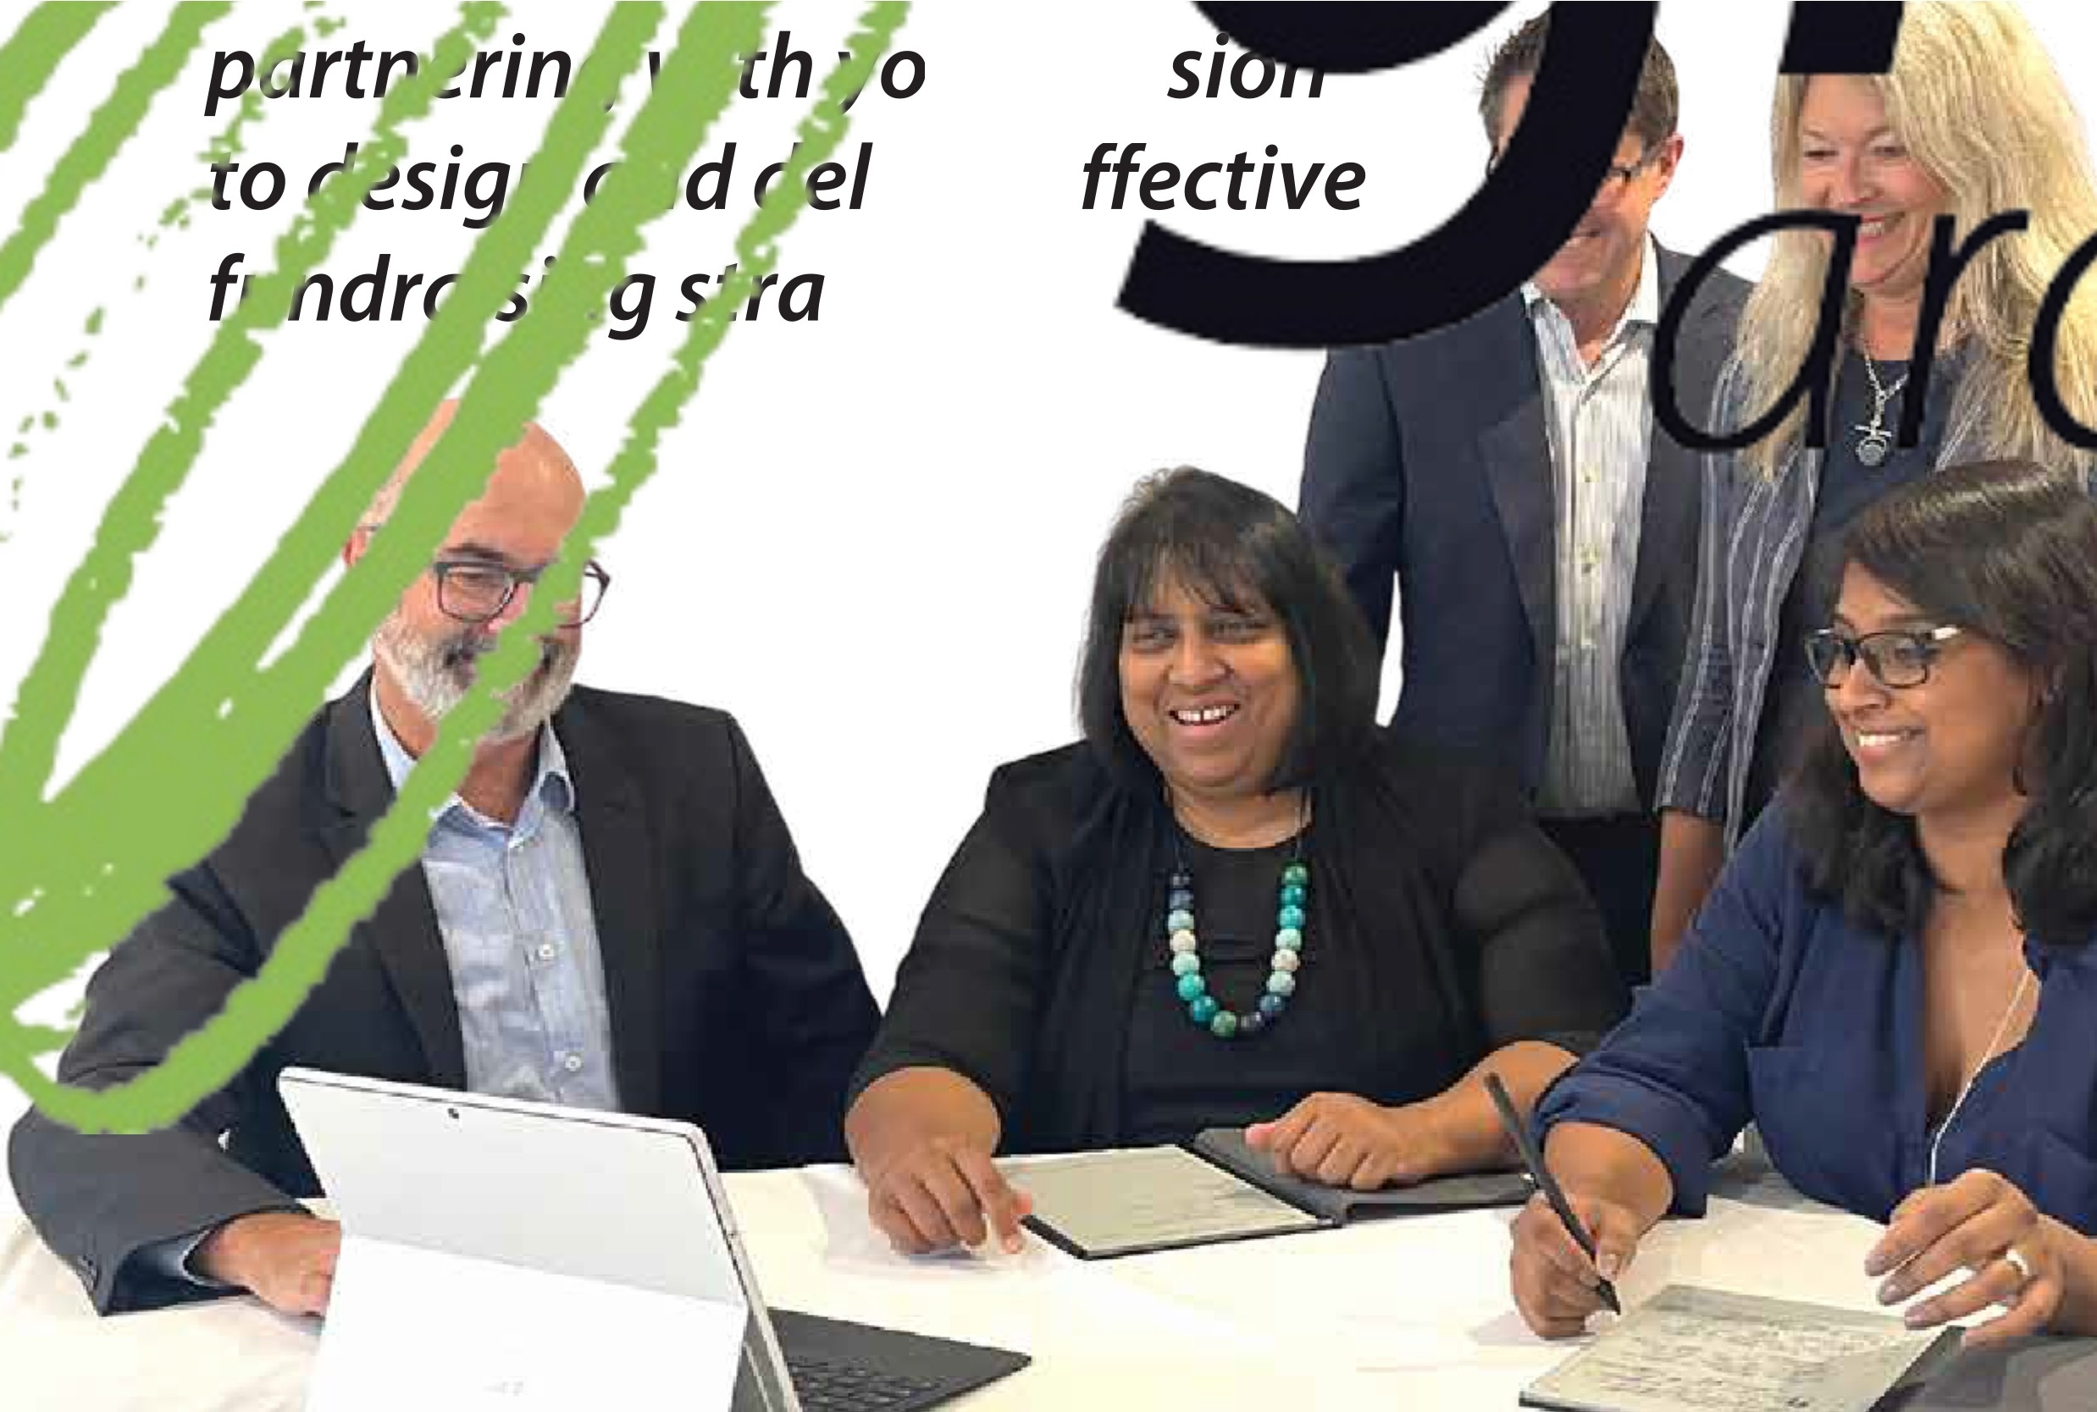,. ,c:!' f:! ,- • oeople and planet

Scan me

isit us at www.givingarchitects.com

urm,•s
,•vere tegies

"The thing Iamproudestofinthiscampaignisthatwemanagedtoachieveourgoalofraising$16.65 million.Whenwesetouttherewasahugetarget.TheexpertiseofGiving Architectswasquitecrucial toachieving alotoftheSuccess."
DanielReddish AdvancementManager AucklandGrammarSchool.

FINZ 2022 Award Winners and Finalists

Best Donor Experience
1
An opportunity to recognise a charity that celebrates putting donors at the heart of fundraising. A not for profit who acknowledges the commitment and support of their donors to the highest level.
2022 Finalists:
- Save the Children
- Variety, the Children’s Charity

The winner was
Variety, the Children’s Charity - Christmas Appeal
Best Individual Giving Campaign
(includes Acquisition, renewal, reactivation and upgrade)
2
This award recognises the skill and expertise that goes into an individual giving campaign, including face-to-face fundraising, digital, DRTV, direct mail, and telemarketing.
2022 Finalists:
- Malaghan Institute of Medical Research
- Philips Search and Rescue Trust
- Save the Children

The winner was
Save the Children – Ukraine Emergency Appeal

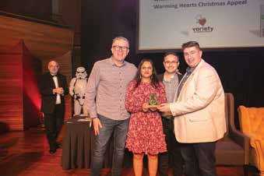
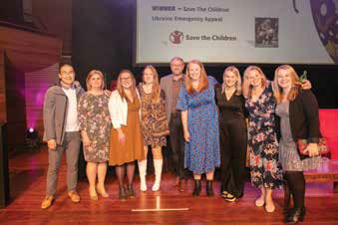
SPONSORED BY
MonDial
telephone fundraising SPONSORED BY

Best High Value Campaign
3
(includes Bequest, Capital, High Value Donors)
This award category recognises exceptional high- value campaigns, including bequests, capital and high-value donors. The judges were looking for a campaign that truly connected with major donors and increased the number of significant gifts to the organisation.
2022 Finalists:
- Sir Richard Hadlee Sports Centre
- Save the Children
- Taranaki Foundation

The winner was
Save the Children – Kiwi’s talking to Kiwis about legacies through DRTV and Digital Advertising
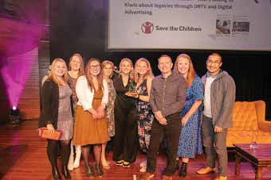
SPONSORED BY
Best Partner Relationship
(includes Corporate, grants & trusts)
4
This award recognises a fantastic relationship that a not-for-profit has with a partner. A partnership that was highly successful for both organisations.
2022 Finalists:
  - Leukaemia and Blood Cancer New Zealand & Farmers
  - The Wellington City Mission & Foodstuffs – New Zealand’s First Social Supermarket
  - Greenlea Rescue Helicopter & Greenlea Premier Meats
The winner was
The Wellington City Mission & Foodstuffs – New Zealand’s First Social Supermarket
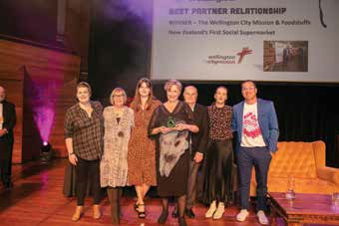
SPONSORED BY

FINZ 2022 Award Winners and Finalists

Best use of Event or Community Fundraising Initiative
5
(including Peer 2 Peer)
This award seeks to recognise a fun-filled community event or initiative that engaged with key audiences and increased income and awareness.
2022 Finalists:
- Heart Kid
- Mercy Hospice
- New Zealand Red Cross
The winner was
Heart Kids – Little Heart Day
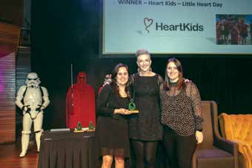
SPONSORED BY
Excellence in Innovation / Most Innovative Fundraising Campaign
How many organisations tried something new last year? Something a bit out of the box and innovative? This award category recognises the
6
year’s most memorable and innovative fundraising campaign.
2022 Finalists:
  - Amnesty International
  - Mercy Hospice
  - The Funding Network
The winner was
The Funding Network – Generosity Generator
SPONSORED BY

Best use of Digital
7
(across all channels)
The criterion for this award is to put your organisation forward as a digital champion, able to connect with a myriad of audiences across different platforms. So which organisations delivered creative and inspiring digital work?
2022 Finalists:
- Leukaemia and Blood Cancer New Zealand
- Save the Children
- Sweet Louise
The winner was
Sweet Louise – Stand Strong 4 Sweet Louise
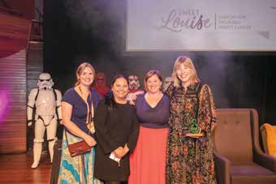
SPONSORED BY
Face-to-Face Fundraiser of the Year 2022
2022 Finalists:
8
  - Andrew Robinson
  - Jessica Impson Davey
  - Peter Narbutas
The winner was
Jessica Impson Davey

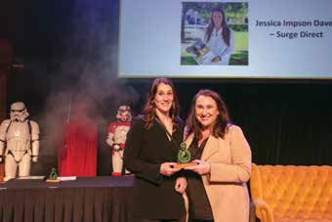
SPONSORED BY

FINZ 2022 Award Winners and Finalists

SCG Precision - Fundraising Newcomer of the Year 2021
9
This award seeks to acknowledge the contribution made by a fundraiser who is new to the sector. To be considered for this award, the person needs to have made an outstanding contribution to fundraising, shown consistent excellence and best practice through their actions, leadership and intellect.
2022 Finalists:
- Amanda Crichton
- Aliya Danseizen
- Lily Kweicien
- Alanna Ramsay
The winner was
Aliya Danseizen – Islamic Women’s Council New Zealand
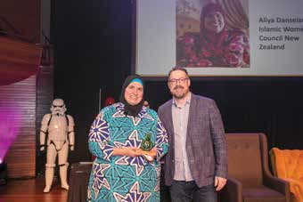
SPONSORED BY
Fundraising Manager
/ Leader of 2021
10
This award looks for a supportive, inspiring and passionate manager/team leader who deserves recognition for their leadership qualities.
2022 Finalists:
  - Karla Paotonu
  - Sasima Pearce
The winner was
Karla Paotonu – Outward Bound
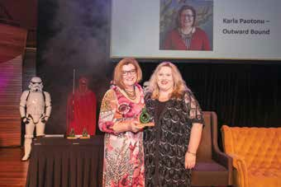
SPONSORED BY

Overall Fundraising Excellence Award
11
This Award recognises and rewards a
not-for-profit’s fundraising excellence. It is not an individual award category, and the winner is chosen from entries into the categories listed above.

The winner was
Save the Children

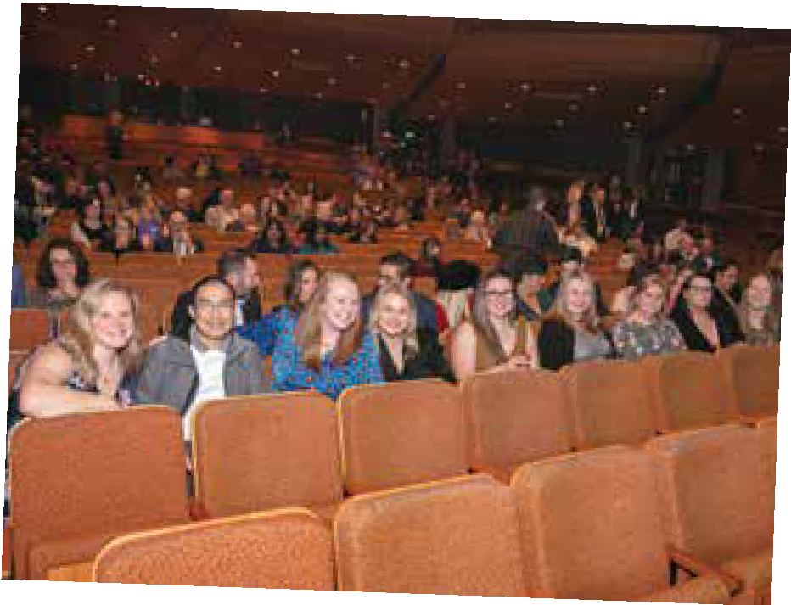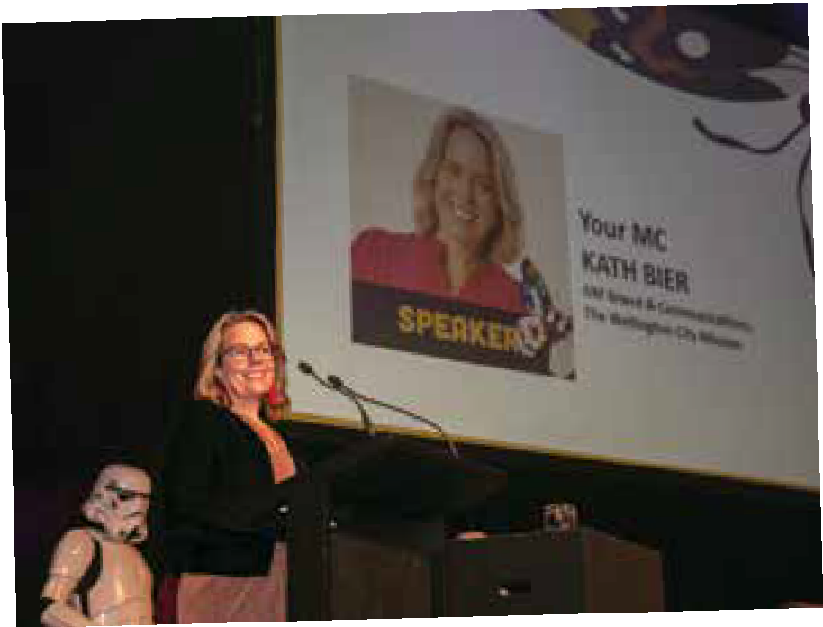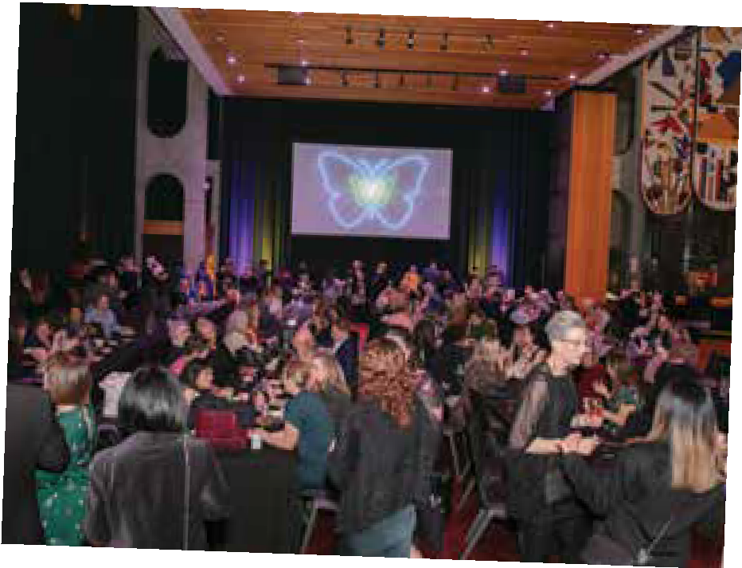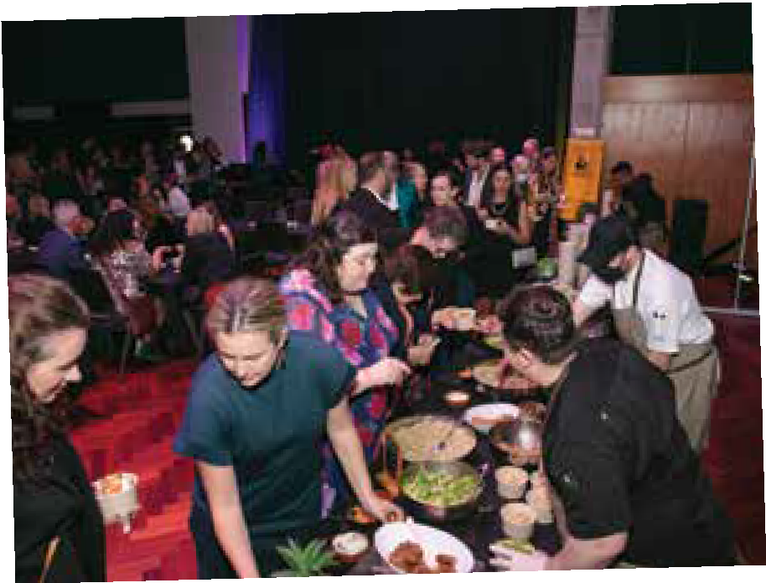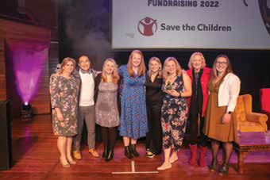SPONSORED BY

www.finz.org.nz | Official publication of the Fundraising Institute of New Zealand | 15

FINZ conference was wonderful this year, the buzz and meeting face to face once more. So many sessions it was hard to decide who to go and listen to. Thanks for
energising my work.

Coming back to conference after three years, was phenomenal. Coming back to conference as a senior fundraiser and with more confidence was the biggest difference for me. I loved the masterclass workshop
with Earle, and the people from that workshop became my
conference friends.

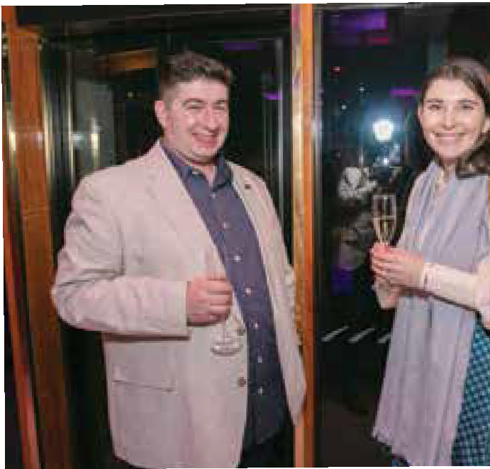It was probably one of the best conferences that I have ever attended. It was exciting, I loved the diversity of people presenting and hope to see more of that in the future. I hope Michelle, the FINZ staff and board are proud of what
they achieved.

My congratulations and gratitude for an enlightening,
highly professional and motivating conference. You brought so many of us together, your achievements in advancing our skills and strengthening
our networks were truly outstanding. . Bringing our community together so beautifully and so seamlessly is and art and a science you have graduated with honours in!

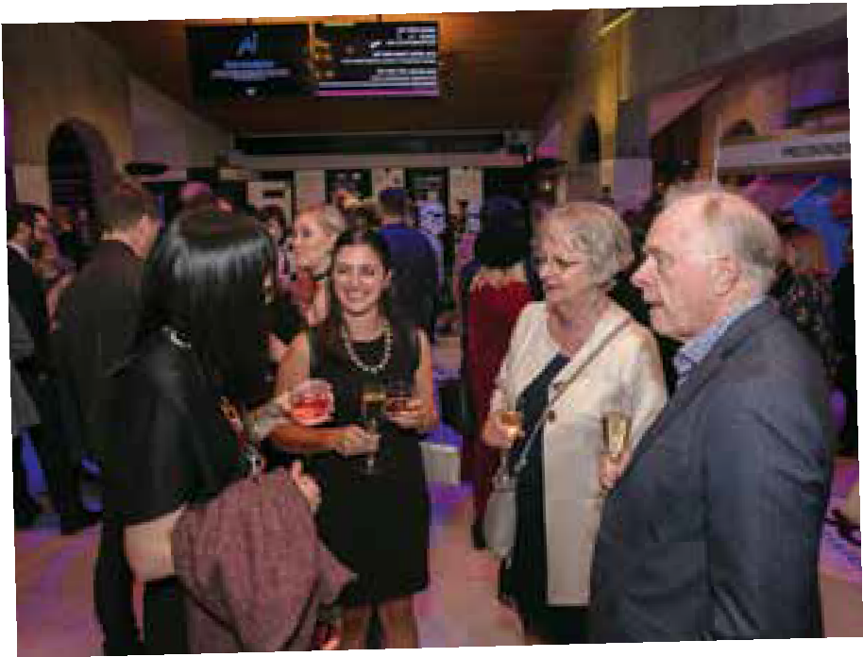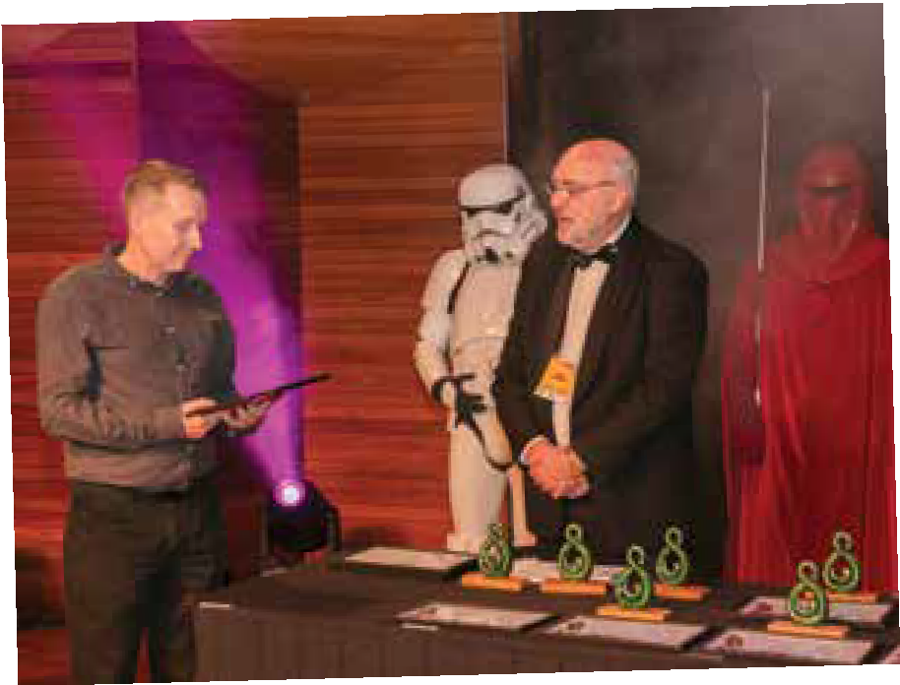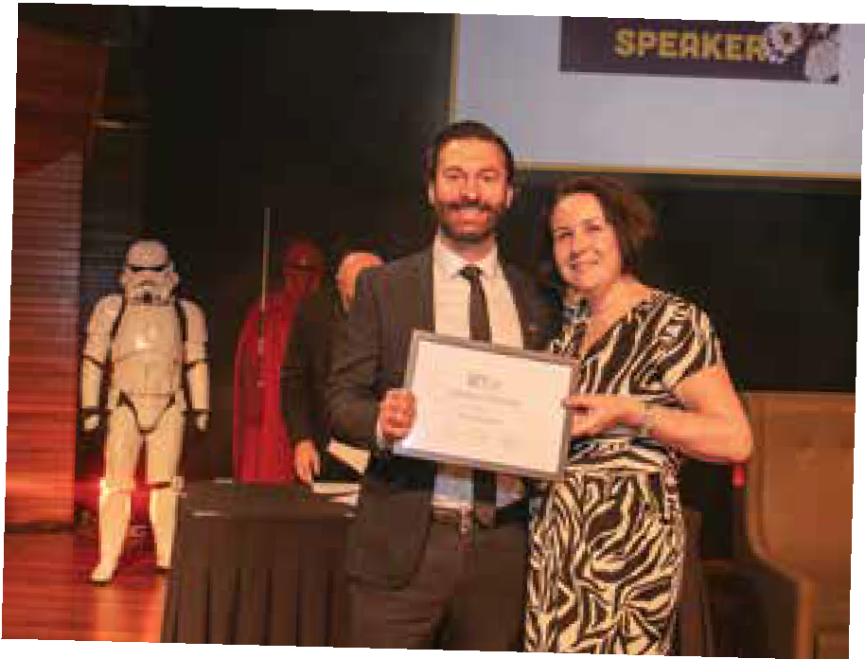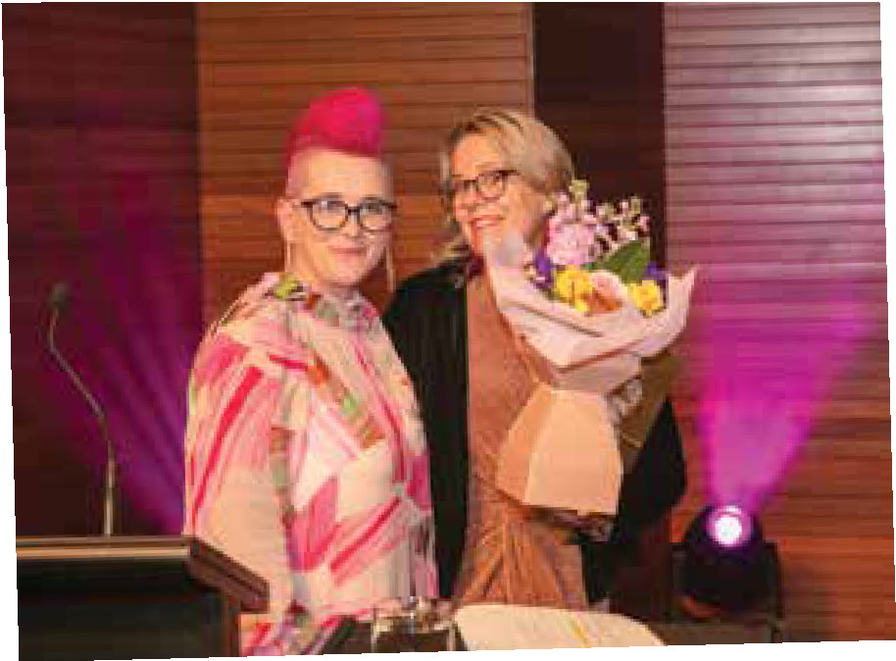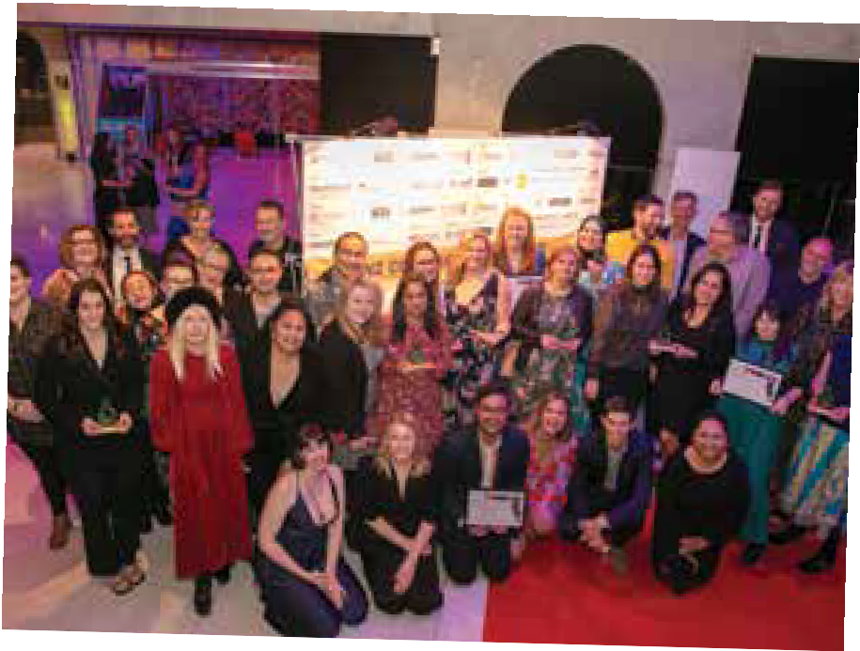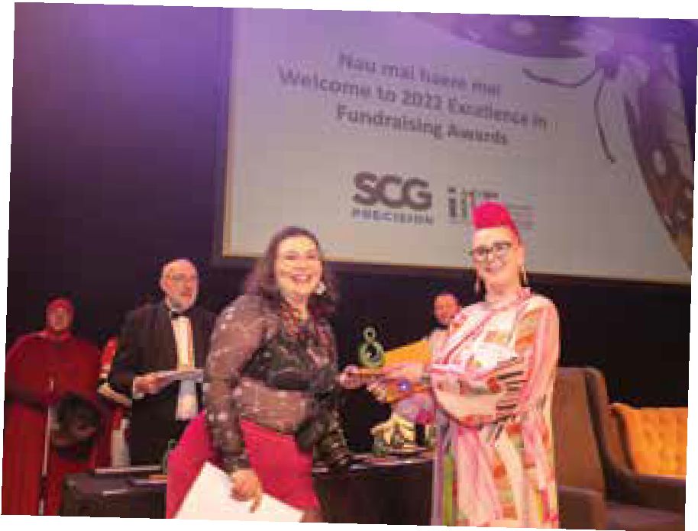Incredible to pull this together given the size of your team and the
environment.

My first FINZ conference and as a conference producer in a previous career, I felt it was very well organised and the venue and
catering were great. Plenty of enticing content and I got some good outtakes. The networking opportunities were a huge benefit of attending, as was finding out what other organisations are doing in the Charity sector.
Well done FINZ.”

I’ve been a regular conference attendee, but this was my first FINZ conference. The organisation was so smooth I didn’t notice it, which is a HUGE plus. I came away absolutely
fizzing with ideas and now I need to bottle them, and serve them to the rest of my organisation - or maybe just drench
them too!!!!!!

Maximise Your Impact with Salesforce for Nonprofits
v Scale Individual Giving Programs
v Modernise Major Giving
v Operationalise Direct Mail v Boost your Digital Fundraising v Simplify the Grants Process

Find out more at salesforce.org/nonprofit

Nonprofit Trends Report

Insights from over 1,600 nonprofit professionals worldwide on how to succeed with technology
The 5th edition of the Salesforce Nonprofit Trends Report is here. Many of the findings are surprising. Others are provocative. The intention behind the report? To help you move your mission forward.

Employee retention and wellbeing are top priorities, second only to fundraising.
Thinking ahead to the next 12 months, how will your resources and priorities shift compared to now? (Answers of “higher priority”)

Fundraising

Retaining staff

Employee wellbeing

Grant-seeking

Investing in technology to streamline internal communications

Program delivery

Investing in data security, integration, and reporting

Marketing and communications

Sustainability or environmental impact
Retaining volunteers Reskilling current
employees

Diversity, equity, and inclusion

Measuring and reporting our impact
36%
38%
38%
40%
41%
41%
42%
42%
42%
43%
44%
46%
48%
The report is based on quantitative and qualitative interviews with more than 1,600 nonprofit professionals in seven countries around the world. We worked with an independent research firm, Reputation Leaders Ltd, to conduct the research. The dozens of charts, tables, and nonprofit CEO quotes — that we struggled to squeeze into its more than 50 pages — provide a thought- provoking overview of the state of the nonprofit sector. It illustrates how technology is supporting nonprofit resiliency and success.
In previous reports, we’ve explored the idea of organisational “digital maturity.” To focus on the benefits of digital adoption for nonprofits, we created the Salesforce for Nonprofits Digital Maturity Index based on answers to five simple questions. This tool helps nonprofits understand where they are on their digital journey.
42%
42%
Every time we have explored this area, we’ve found that nonprofits that score better on this Digital Maturity Index are significantly more likely to exceed their mission, fundraising, volunteering, and other goals. The same is true in this edition.
But what about organisational culture? As we emerge into a post-pandemic world, nonprofits in every country

are working to steady themselves. They are renewing relationships with donors, volunteers, and hard-to- replace employees. Indeed, the report finds that, after fundraising, the top nonprofit priorities for the next year are “retaining staff” and “employee wellbeing.”

Digital maturity fortifies relationships with all stakeholders.
How would you rate the strength of your organization’s relationships with the following stakeholders? (Answers of “strong” and “very strong”)

81%

This is understandable since we found that only a quarter of nonprofit employees or managers said they felt highly motivated.
Beneficiary recipients

The general public
33%

40%
68%

75%
65%

Only a quarter of nonprofit professionals are highly motivated.
On a typical day, how motivated do you feel at work in your current role?

In-country program partners

ntmaking organizations

27%

58%
74%

73%

10
Highly motivated
9

8
Somewhat motivated
7

6
Passive
5

4

8%
17%
23%
18%

11%

6%

8%

Total

25%
Highly motivated

41%
Somewhat motivated

17%
Passive
or foundations

Other similar nonprofits

Employees

Government or regulatory bodies

Volunteers

Media

Donors

31%

37%

42%

38%

33%

23%

27%
63%

68%
56%

67%
58%

66%
58%

64%
56%

64%
54%

62%
54%

Demotivated
3 6%

2 3%

1 0%
17%
Demotivated
High digital maturity Medium digital maturity

Employees Are at the Centre
Low digital maturity

0 0%

Evaluating Relationships That Drive Change
This year, we wanted to expand our understanding of nonprofit relationships. We explored the impact of digital maturity on nonprofit relationships — particularly with external stakeholders and employees. We asked: Does the digital maturity needed to create a data-
informed organisation improve relationships with donors, volunteers, and employees?
The answers were revealing. We found that nonprofits with higher digital maturity said their relationships
with all stakeholders were stronger — particularly with program participants. This confirms that investing in digital infrastructure supports not only fundraisers, marketers, and employees, but, most importantly, the program participants that are the priority for many nonprofits.
Aside from fortifying relationships, high digital maturity offers benefits for nonprofit staff. Digitally mature nonprofits were:
- 3.5x more likely to say they have highly-motivated employees
- 1.7x more likely to say their organisation had a healthy workplace culture
- 1.3x more likely to have lower levels of staff burnout
- 1.7x more likely to be optimistic about the future of their organisation
As we all adopt digital technology in our personal lives, it makes sense that nonprofit employees thrive when automation reduces manual work. With technology that simplifies their work life, employees can focus on what matters.

What’s Next for Digitally Mature Nonprofits?
Digitally mature nonprofits are successful nonprofits.
So, what are next year’s priorities for them? They’re planning to focus on cybersecurity and data privacy, add new programs and services, and further embrace remote work.

The fifth edition of the Salesforce Nonprofit Trends Report covers much more, including:
- Which cause areas have the strongest and weakest relationships with donors, volunteers, employees, and regulators
- The differences between how nonprofit senior leaders and managers describe their workplace culture
- How many nonprofits have recently made Diversity, Equity, and Inclusion (“DEI”) efforts, and what those were
- How many nonprofits have sustainability targets, and what progress they have made

For these and many other insights, download the 5th Salesforce Nonprofit Trends Report below.
Get your free copy of the Salesforce Nonprofit Trends Report.

Juliet Rize
Product Marketing Manager at Salesforce.org
John Jensen
Senior Director of Nonprofit Insights at Salesforce.org John works to help Salesforce.org serve nonprofits by building the broadest possible understanding of the sector’s goals and challenges across the world. Prior to his work at Salesforce.org, John led corporate strategy and more at Mozilla as well as market research at other firms. He is based in Vancouver, Canada.

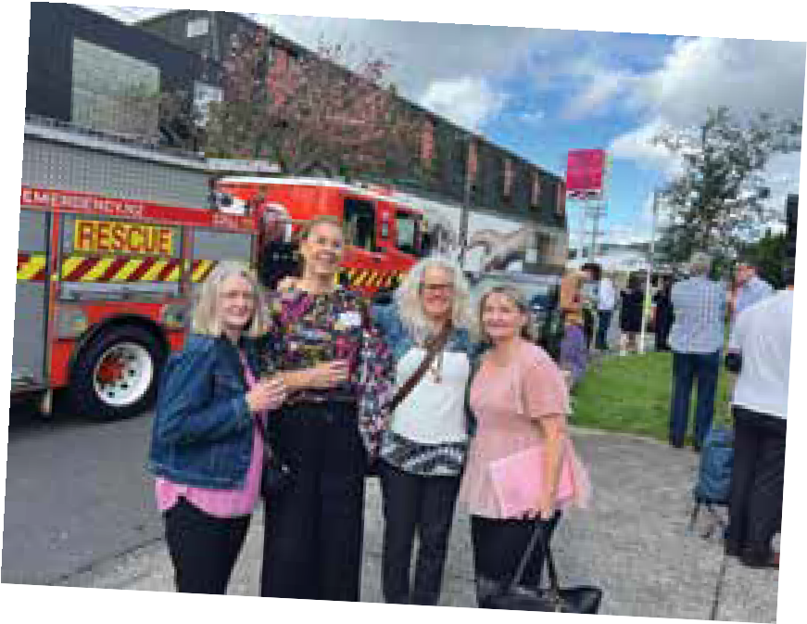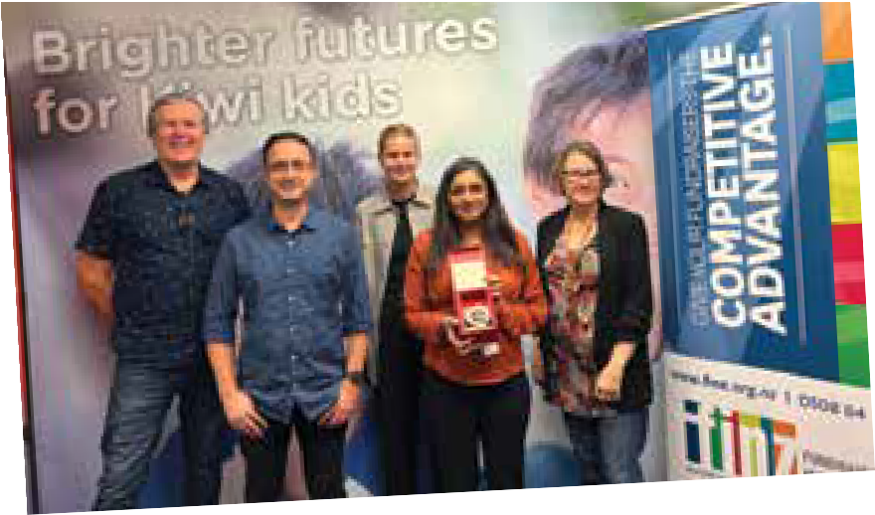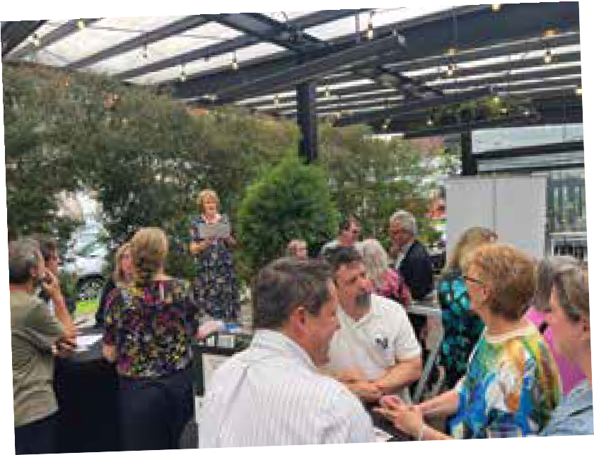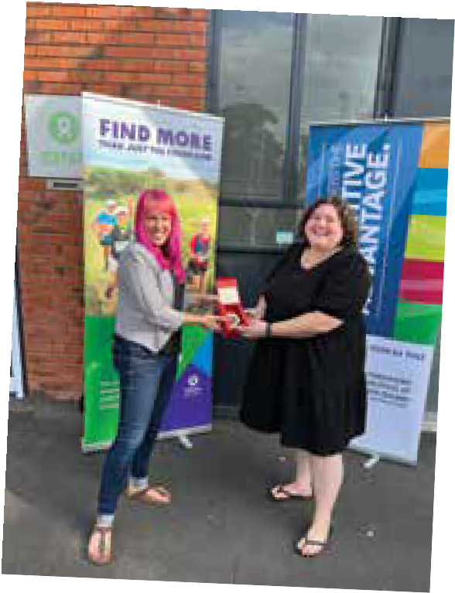FINZ
Membership Matters
I have been a member of FINZ for around 23 years and it has been a wonderful and valuable relationship for me. When I first started out in fundraising, I knew nothing about professional fundraising, but I was lucky and went to my first fundraising conference at the end of the 1990’s and there my learning journey began. I have been learning about fundraising and making wonderful friends with my fellow fundraisers ever since, all thanks to FINZ!
DOMINIQUE LEEMING

FINZ membership allows my team and I to access training and information vital to help us stay on top of the latest market trends and inspirational fundraising ideas. But more importantly, it keeps us linked with our fellow fundraisers across the country, building networks for when we need
to simply ask a question that only other keen fundraising brains will know how to answer or we are looking for some support from our peers in what can be a rewarding but tough industry to work in. The last couple of conferences have been a particular highlight for me personally, finding support and kindness as I was traversing some complex work challenges, whilst being blown away by some of the inspirational fundraisers from New Zealand and across the world.
LAURA GOLLAND, MALAGHAN INSTITUTE OF MEDICAL RESEARCH”

As a consultant I value my membership with FINZ to inspire, inform and keep me involved in the sector and networking with other industry professionals. I appreciate the learning and education, exclusive resources,
growth and development FINZ offers for personal and professional development. This year’s Conference was incredibly worthwhile for connections, conversations and collaboration. (on brief, on budget and on the ball) My FINZ membership strengthens and expands my knowledge, skills and practice and that equips me to offer more in mentoring and to my clients.
JENNY CASTON, WILLPOWER

FINZ’s work is crucial for a thriving for-purpose sector, providing thought
leadership and access to quality fundraising education. Community Foundations of NZ sees it as important to support the growth of professional fundraising practices and ethics
across the for-purpose sector and we are very proud to be FINZ members.
ELEANOR CATER, COMMUNITY FOUNDATIONS

An elegy to Admin costs
No, I’m not a poet. And yes, I spelt that wrong – I really meant allergy.
Q: Can you please assure me that none of my donation is going to be wasted on administration?
A: Those charged with utilising the money you donated are out there doing the mahi. Unfortunately, those of us employed to support them are concerned at wasting your money answering your question.
“How much of my donation goes on admin … or overheads?” I know you get the question, so let’s get real about the answer.
It will be a proportion. It might

be a small … or it might be large, shock horror! But it is never none of it in reality because even if all of a donation gets directed strictly
and solely to some specific appeal target, someone has had to pay the cost of raising, directing, accounting and facilitating that result..
So, why do we kowtow to the myth that there are no overheads or administration costs associated with seeking, processing and expending of donations?
Imagine McDonalds promoting the sale of a Big Mac for which you only had to pay for the ingredients! It’s totally illogical. The Company would be bankrupt in
a week. Someone, somehow, has to pay for the people resources necessary for purchasing, cooking, packaging, promoting … and paying for of the ingredients and disposing of waste. There’s the cost of the buildings, equipment, delivery and warehousing. There’s the cost of people recruitment
and management, financial accountability. And then of course, there are the compliance costs of doing business.
It’s exactly the same for charities.
There is a cost to the donor of raising each donation, of receipting, tracking and assigning money able to be spent on a specified purpose, and of appropriately reporting back and being accountable.
The truth is that ‘admin’ is not an ‘overhead.’ It is in fact a mix of
infrastructure and compliance costs. Both are absolutely inescapable.
They’re not niceties or some sort of sinecure that gives someone a job just for the sake of it. Both require
the application of skill – often-times qualified professional skill. And that, costs.
Ponder for a moment the scenario where a donor wants their dollar to be spent solely on
some specified service or activity. If absolutely every last donated dollar is to be used solely for that purpose, then the donor needs to do it themselves - take their donation and physically deliver it to the specialist or volunteer who is doing the work – wherever in the world that might be – and give it directly to them. Or better still, do the work themselves, to make sure that the dollar is spent wisely.
Impossible right? In short, yes. That is why we establish organisations – to do the work on every donor’s behalf. Not
surprisingly, that costs. It even costs to recruit, engage and facilitate work done by volunteers! Charities run entirely on volunteer labour
also have inescapable costs – the costs of providing the appropriate associated infrastructure and of meeting compliance obligations.
It is reasonable to assume that people don’t wake in the morning and suddenly decide to give money away. It may happen but it’s not usual, right? People give primarily because they are asked and they are motivated. An issue is brought to their attention and a decision is made on the basis of the information provided, that they wish to contribute. There is a cost to providing that information and for asking for a contribution. Is it unreasonable that a proportion of
the cost of providing the information
and making the ask not be covered as a legitimate cost against the donation made? The answer is ‘no’ – otherwise, how could the issue be brought to a donor’s attention?
Not everyone who is asked will give – at that point in time to that specific appeal – meaning that some of the expenditure associated with informing people and asking for a donation will be ‘dead money.’ No-one wants that. But it’s a fact of life and inherent in the fundraising principle of ‘never making up a donor’s mind for them.’ It is simply an ‘ask.’ Donors will decide whether the time is right, the ask sufficiently compelling and they are sufficiently motivated to give there and then.
Criticism that can be levelled, is if someone indicates that they are not interested and the organisation continues to ask. Otherwise, the criticism is baseless.
So, that brings us back to the question of ’admin costs.’ If anyone knows how these might be avoided, there are thousands of legitimate charities that would love to know how. Because, all that is known and understood … and unavoidable …
is that there are both infrastructure and compliance costs that have to be met sometimes even before any funds are able to spent on service delivery.
Charities worth their salt, ensure that whatever those costs might be, there is maximum funds left over to contribute to whatever donors have decided to contribute towards. That is the reason why most people work for charities – we want the same outcome.

Save the Children: Adapting to change in the digital space

Whether we like it or not, change has become the “new normal.” The pandemic pushed charities into the digital space more than ever before and since then it feels like change is non-stop.

In the ever-changing digital landscape, we’ve had to shift our way of thinking and strategy in order to adapt quickly. The
recent “Status of Digital Maturity of Nonprofits in ANZ” Blackbaud benchmark report found that even though growth and digital innovation are both trending upwards, overall the sector
rates itself as just under 4.5/10 for digital maturity as well as
demonstrating a desire to develop their digital capabilities.
So it’s good to know we’re not the only ones feeling this pinch, and if you’re just starting your journey in
digital, it’s easy to get overwhelmed.
We’re not the experts, but we have learned a few things over the last year which may be valuable to people finding their feet in the digital space.

Here are some of our key takeaways
- Take stock of what you’re doing now digitally and look at what you can optimise. For example, make sure your website is mobile friendly. Integrate your campaigns that you’re using in your offline fundraising across
your digital platforms so that users are exposed to the same message repeatedly.

- Check the friction on your most important digital asset – your donation page. Are people getting stuck in particular places and not donating? Use a heat-mapping tool like Hotjar to track user experience and uncover the points of friction
and minimise them. Or if they’ve been lingering on the page for
a while, try asking your donors what’s stopping them from donating with a popup question.

Save the Children Digital Marketing Manager, Kat Piper, specialises in innovative integrated marketing campaigns that delivers growth in revenue and brand awareness. With more than six years’ experience across digital and peer-to-peer fundraising in Australia and New Zealand, works to build and nurture our supporters by providing engaging digital content, bespoke user journeys and new ways to support the movement.

Stop asking for non-critical information on your donation page! Or at least don’t make it mandatory. The more fields you’re asking your donor to fill out, the more likely they’ll get fed up with the process and
leave your site. Or even better – ask them for those details after they’ve submitted their donation!

  - Our supporters’ expectations of how they want to interact with us online are changing –they expect us to work just like Amazon! They want things to be quick, easy
and obvious. How easy is it to get to a donation form from your homepage? Is it easy to buy from your online shop?

- Know your audience(s) so you can target the right people with the right message at the right time.

- What worked for digital ads on Facebook six months ago or even yesterday (literally) doesn’t mean it will work today – so have a plan
B. The algorithms change and rules around what Facebook will let you show, particularly around sensitive issues, have tightened.

- Take the rest of your organisation along for the digital ride. Regularly share what you’re doing, the challenges you’re facing, the new things you learn along the way and most of all results. As users themselves, they’ll surprise you with insights and you’ll create allies to help you in the fight for more investment. If they see it working and helping their fundraising, they’ll be your biggest fans.

- Test before you invest in a full- blown digital ad campaign

- Digital campaign not going as you’d hoped? Try a creative refresh before you go back to square one, it could save you time and dollars. Change out images, add new creative or graphic elements, or tweak the
copy, all so the user feels like they haven’t seen that ad before.

- If you’ve been running a successful campaign but the results have dropped and it’s become more expensive than you’re willing to pay for, consider resting the campaign. We recently gave one of ours a three- month break and it’s come back roaring.

- Lean into learning. This one might feel obvious, but as creatures of habit we can get stuck in our ways. It’s easy to lose confidence when so much change is happening and that’s normal. Embrace it, learn from your peers and keep abreast of upcoming changes so you can be ready to adapt rather than caught on the back foot. We’re a big fan of Google Ads best practices newsletter as well as SEMRush. These companies also offer free training resources to help get you started!

- Finally, if you’re a small team or one-person shop with big digital advertising dreams, find yourself a good digital agency. They will be able to throw more creative and analytical brains at your campaign and spend more time optimising your ads than you will. It will also buy you time back to focus on all of the rest of the stuff mentioned above.

FELLOW S

FINZ welcomes and congratulates two new Fellows appointed at the 2022 FINZ conference.

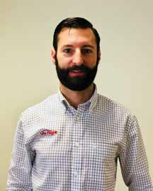
Sebastian Grodd

With over 17 years in fundraising and not-for- profit sector experience, Sebastian has been instrumental in leading transformational change for a regional charity - Life Flight - which now punches above its weight alongside New Zealand national charities against benchmarks (IVE, formerly Pareto)

He has been a member of FINZ for 16 years and has attended approximately 10 Conferences, presenting at four. Seb has also been on the Conference planning committee for the last six years, specifically creating the speakers programme. He also was an IWITOT (I Wish I’d Thought of That) speaker in 2021 and co- hosted an international on-line fundraising summit in 2020 with Fundraising Everywhere.
Sebastian has supported all local FINZ events including
providing a free venue for speaker tours over many years. He always sends his full team to professional development opportunities.
During his tenure at Life Flight Seb helped achieve the following -
Designed and implemented a transformational, multi-channel strategy. The plans required a restructure, upgraded database system and new funding initiatives. Sustainable annual revenue increased by 40%
Increased the direct mail appeal income by 33% creating $1 million per annum from 11,000 donors.
Appeals won awards: Gold award winner in not for profit sector, New Zealand Marketing Awards 2015 and Silver in the B2B sector. National award winner for best acquisition campaign Fundraising Institute of NZ Awards 2014
Increased customer acquisition by 90% and retention was 10% better than Australasian benchmark for the sector.
Oversaw the production of Life Flight’s reality TV show which had the highest ratings after
TV1 News. Unprompted brand awareness increased by 25% and prompted awareness by 13%. Now unprompted awareness stands at 55%
Revamped all communication materials including online which resulted in a 400% increase in online donations.
Stewarding and relationship managing the corporate sponsorship with Westpac - now in its 40th year!
“These are just a few of his achievements during that time. Above all he is a man of values that he upholds and exemplifies at every
moment. “He’s probably one of the best fundraisers, marketers and communicators for the not for profit sector that I have had the honour of working with” said Candy Schroder (Seb’s Line manager until 2015)
Seb has a gentle coaching leadership style and takes people with him effortlessly. His longevity in the sector has been anything but effortless. In earlier years
at Life Flight he worked hard to establish best practice, multi- stream fundraising in a relatively low trust environment. Back then communications needed checking by the Chair! Through patiently crafting a storytelling approach, year-on-year testing has enabled successive leadership of the organisation to be fully on board with fundraising. Now there is a diversified multi-stream fundraising operation covering 8000+ regular givers, appeals, major gifts, legacies and a mature corporate sponsorship programme - all totalling $6M annually.

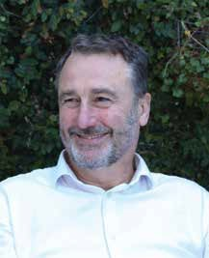
Greg Millar

Greg Millar is an internationally recognised fundraising professional with over 30 years of experience in the not-for-profit sector who has brought a wealth of overseas knowledge and expertise to the New Zealand fundraising space.

During his time overseas he worked with UNHCR in Rome and Washington, and
UNICEF in Geneva. His New Zealand based work included Head of Fundraising for WWF, Fundraising Manager for Auckland City Mission and he is currently IHC New Zealand’s National Fundraising Manager.
Greg has long been dedicated to the fundraising sector. He is
a strong advocate for innovative and best practice fundraising and enthusiastic supporter of individual fundraisers across NZ, lending his time to provide feedback, support, and mentorship to many. He
has also held volunteering roles,

including as Chair of the PFRA Board of Trustees.
Going hand in hand with this commitment to the sector, Greg has been a vocal backer of the Fundraising Institute of New Zealand (FINZ) across his career, showing an unwavering support to the organisation. Including -
  - Being a member for approximately 20 years
  - Being a volunteer member of a Conference Organising Committee
  - Being member of the Judging Panel for the 2020 Awards
  - Regularly participating in FINZ events and attending regional fundraiser gatherings

  - Speaking at past Conferences
  - Supporting of events on social media
  - Writing for the magazine on multiple occasions
Under Greg’s management, IHC holds an organisational membership for the Fundraising team. This is to guarantee each team member has access to FINZ
resources and learning. He strongly encourages the team to participate in FINZ events and opportunities, including yearly Conference attendance.

FINZ congratulates Fiona McFee and Sean Triner for having been made Fellows of Fundraising Institute Australia at the FIA conference held in Melbourne in February 2023.
Fiona becomes only the third New Zealander to have achieved FFIA status.
This document is printed on Sumo Matt, an environmentally responsible paper, produced using Elemental Chlorine Free (ECF), Third Party certified pulp from Responsible Sources, and manufactured under the strict ISO14001 Environmental Management System.

“You wouldn’t cancel on yourself”:
Anastasia Papadakis, CFRE, on investing in your fundraising practice.

- What do you think is the biggest misconception about being a fundraiser?
That our days are filled with long lunches, schmoozing, and million-dollar cheques. If only! I spent most of my last lunch with soup and a spreadsheet.

- What is the best career advice you’ve ever received?
If you aren’t happy, change something. Change your attitude or change your role. Life is too short to sit in unhappiness.

- As a Donor Development Manager at a university, what has been your most pressing fundraising challenge over the last 18 months? How have you and your team risen to the occasion?
As with most organisations, it’s time. Finding time when you, your researchers/academics/ programme team, and your donors are healthy, available, and have the frame of mind to

consider their philanthropic relationships.
To get through this we have to acknowledge we are still in
‘unprecedented circumstances’ and to be patient—adjusting timelines and expectations.

- What is the most rewarding part of your work?
It’s very sappy, but it’s seeing the joy on our donors’ faces when they achieve their philanthropic goals and affect the change
they want in the world. Real heartstring stuff!

- As fundraising professionals move up the leadership ladder, it is easy for their professional development to fall to
the wayside. You are a current FINZ member and keep up with fundraising education to earn and maintain your Certified Fund
Raising Executive (CFRE) credential. What are your

tips for making time for professional development when schedules already feel full?
Take yourself on a date. Diarize time each week to sit with your favourite hot beverage and some interesting enewsletters, articles, webinars, or magazines. And remember, you wouldn’t cancel on your most important donor so don’t cancel on yourself—the
piece you read today may just be the thing you need to get a donor across the line tomorrow.

- Many fundraising professionals think, “I’m hitting my targets.
I don’t need to attend fundraising conferences or courses. I’m sure
my learning is up to date.” For people with that approach, what would you say to encourage them to
take a more active role in their professional development?
Your donors don’t care about

your targets. They care about how they are treated by you and your organisation.
To ensure they have the best possible experience from your organization (as time and budget allow), you must be constantly surveying the landscape for the most innovative ways to care for them. Or they will leave you for someone who is.

- When did you first join FINZ and what do you view as the most
valuable aspect of being a member?
I was exceptionally lucky that one of my earliest managers (the fabulous Taleen Khallili) encouraged a love of learning and took me along to FINZ Learning Lunches. Since then, I’ve held a membership and appreciate it deeply. I very much value the people I have met and the generosity with which they share their knowledge.

- In February 2022, you became a Certified Fund Raising Executive (CFRE). What motivated
you to earn a fundraising certification?
It’s been ten years since I fell into fundraising. And by fell, I mean fell in love. A love that took me completely by surprise (as these things often do) and having found such a match, it was only fair I took things to the next level and made our love official with
a signed document that I could frame.
But in all seriousness, it was my way of moving out of fundraising as a ‘job’ to fundraising as a profession. It is a sign to all those
I work with that I hold myself to a high professional standard and do so with integrity.

- What has been the most prominent benefit of being a CFRE?
As with FINZ, it’s the people. The connections I made, and continue to make, within the international CFRE community have been incredible. There
is a wealth of knowledge and the members are exceptionally generous with their time in sharing it. It’s a privilege to be a part of this community.

- What advice do you have for others considering becoming a CFRE?
Start the process today! The application requirements can seem overwhelming at first (you must meet a certain number of ‘points’ in Education, Professional Practice, and Professional Performance).
Put aside just 15 minutes, create your login, and start popping in the points information you have easily to hand. Just like eating an elephant, do it one bite at a
time. When you have some spare time, log in and enter a few more points.
When you come to studying for the exam, make a timetable and stick to it! The practice exam
is incredibly useful, as are your fellow CFRE candidates. There are study groups and regular emails sharing tips, tricks, and example questions.
There are four comprehensive books listed on the CFRE website which are all very useful, particularly for any areas you lack experience in.
- The last two years were full of upheaval and now the word ‘recession’ is on everyone’s lips. What do you think will be the number one challenge for fundraisers in the upcoming 12 months?
Maintaining personal resilience.
There will be greater need from the beneficiaries our
organisations service and greater dependence on fundraising income.
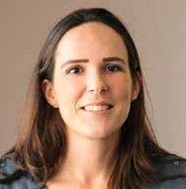Our To Do Lists will grow, as will the pressure to bring in funds. Finding a way you can ‘clock off’ and recharge will be key to meeting these challenges.

Anastasia Papadakis, CFRE, marked 10 years as a fundraiser in 2022. In a field where it’s not uncommon for people to cycle through, Anastasia’s passion and commitment to fundraising have helped her persevere. She talks to us about what she sees as the top challenge for fundraisers in an impending recession, her love of fundraising, and her journey to become a Certified Fund Raising Executive (CFRE).

One fundraising certification, a world of possibilities
The Certified Fund Raising Executive (CFRE) certification is the only globally- recognised, accredited certification for fundraising professionals.
By becoming a CFRE, you prove to your colleagues, donors, board, and beyond that your fundraising knowledge is based in globally-accepted best practices. It demonstrates your unwavering commitment to ethical fundraising and professionalism.
Whether you fundraise in Auckland, Melbourne, London, or anywhere else in between, as a CFRE you will set yourself apart as a fundraising professional working to the highest standards.

Learn more at www.cfre.org/certification/initial
30 | Official publication of the Fundraising Institute of New Zealand | www.finz.org.nz

Advocacy update
FINZ plays a key role advocating on matters that affect charities’ ability to operate effectively and efficiently, including any matters that might or do impact on fundraising reputation and success.

2022 was a busy year on that front. Here is a brief outline of some of the key advocacy work undertaken during the year.

Charities Amendment Bill
Changes to the Charities Act 2005 were signalled back in 2017. FINZ became actively engaged in the consultation processes that took place in the lead up to the introduction of the proposed Charities Amendment Bill in late 2022. FINZ submitted several times during the process with the final submission being on the proposed Bill itself. The general and consistent theme of FINZ submissions were to oppose the Bill and to call the government to
account for and follow through on what had been Labour pledges since the passing of the original Act, to have an independent ‘first principles review’ of the legislation. That was even a stated pledge in the 2017 Labour Party Manifesto which of course was the election that swept Labour into power under Jacinda Ardern’s leadership.
The Bill introduced to Parliament late last year proposed to ignore that pledge and focus on a raft
of administrative changes. You are encouraged to read the FINZ submission which can be found at https://www.finz.org.nz/advocacy. Class 3 Lottery regulations
Under current legislation, charities have been specifically forbidden to promote or sell Class 3 licenced lottery tickets on-line. These are the most common lotteries conducted by charities. Under Emergency COVID restrictions, the government made
limited exception for both The National Heart Foundation and Coastguard NZ. The exception was due to expire in 2022. FINZ made a strong submission that this
exception not only be extended but also applied to all Class 3 lotteries. FINZ was invited to speak to our submission at the Finance and Expenditure Select Committee.
Our request was granted and the regulations changed. Our work here is not however complete.
The regulation changes are due to expire in 2025. FINZ is now lobbying the Department of
Internal Affairs to have the changes permanently enshrined in the Gambling Act.
Demise of cheques
Working with all the major banks to minimise the impact of withdrawal of all cheques as a means of transacting was a huge piece of work for FINZ. Through the advocacy of FINZ, a working group of all the major banks was able to be established to enable a cooperative approach to the
changes and assistance to charities. Being able to keep FINZ Members updated and informed is believed to have helped minimise the impact on donors who traditionally favoured supporting by way of cheque payments. It is especially pleasing to note that the changes do not appear to have had the predicted negative impact on giving.
Mastercard Merchant rule changes
Mastercard announced rule changes during the year that would have required charities to provide receipts and instructions on how to opt out of or change arrangements for every single donation received.
This would have applied to all regular donations, adding
significant administrative burden on charities and some confusion for donors. While affected donors could choose to not receive the receipts and information every time. But that of course would have had charities needing to track who received what, when. Working in concert with Fundraising Institute Australia and other third parties, lobbying managed to succeed in changing the proposed rules so that donations would be exempt.
Just note however, if you subscribe regularly to something, for example Gym membership, then this rule will apply to those types of transactions. Performance Reporting
The rules for how charities report their annual finances to Charities Services is led by an independent body called The External Reporting Board (XRB). Changes in reporting requirements were made some years back, coming into effect for the 2016 reporting year. Further changes were proposed during 2022 and FINZ made a submission on the proposed changes. While technical in nature, our prime recommendation was for more detailed reporting on fundraising revenue so that FINZ and others, could track changes in fundraising behaviour and trends. We await the outcome of our submission.

In retrospect: Key learnings from 2022
for effective fundraising in 2023 and beyond
The Giving Architects team across New Zealand and Australia had the privilege of working on some truly transformational projects in 2022 with several amazing for-purpose organisations. A few interesting observations were made as we navigated through last year with these projects and mingled and participated in fundraising-focused events with fellow fundraisers on both sides of the Tasman. Based on these observations and best practices, here are a few key learnings from the team to take with you for a more sustainable and effective strategic approach to achieving your mission in 2023 and beyond:

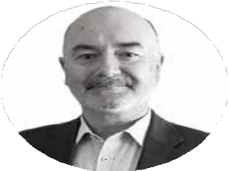Long-term focus on donor care efforts will yield results
Thoughts from Clive Pedley ( Director and Chief Executive at Giving Architects)
All the data and trends in 2022 continued to point to the fact that individual giving was the important backbone of philanthropic revenue in the for-purpose sector. More specifically, it highlighted that the gifts of significant monetary value were an increasingly significant component, even during the challenges of the pandemic and the emergence of a high- inflation environment. This should be no surprise. It is part of an ongoing trend and reflective of fundraising norms that stretch back decades in most western economies.
The challenge is that not all for-purpose organisations are prepared for or able to adjust the investment of resources, time and effort required across the whole organisation to achieve optimum fundraising outcomes. Long-standing donor relationships, only made possible through great donor care and the demonstration of the impact made possible through generous support, are the most significant factor in for-purpose organisations achieving great outcomes in this space. What we observed in 2022 was that careful and deliberate work is required to capitalise on what is ultimately limited opportunities, or that organisations need to commit now to a long-term effort when it is apparent that the key ingredients for gifts of significant monetary value are missing.

Building sustainable futures – A powerful story alone is not enough
Thoughts from Iyanthi Wijayanayake ( Director at Giving Architects)
Adversity brought about by a global pandemic and impending economic uncertainty impacted organisations in different ways in 2022. Change is inevitable. But change also brings about opportunities for organisations. Forward-thinking sector leaders and agile fundraising professionals encouraged cross-functional engagement, committed to understanding and measuring impact, and engaged with their donors with authenticity and had great fundraising success in 2022. While meeting the needs of beneficiaries is critically important, critical to meeting this need are the teams and donors. Focusing on beneficiaries alone is potentially short- sighted and unsustainable. Organisational leaders must support and encourage donor-centric fundraising to unlock the philanthropic ambition of donors. Communicating to donors about their role in partnering to deliver greater impact is a necessity. An organisation can only do this if they commit to focusing on defining and measuring impact. Measuring impact will also allow an organisation to innovate, measure success of programmes, communicate with clarity the difference made and how their purpose is fulfilled. Meeting the organisation's purpose and fulfilling its mission is about your people and your donors as much as it is about your beneficiaries. The impact strategy is critical to measure and report on impact. Organisations cannot fulfil their mission by just surviving. Surviving is not enough! Organisations must thrive.

In 2023, just sharing powerful stories is not sufficient. These amazing stories must be backed by data. There are no stories without numbers and there are no numbers without stories.

Driving positive change for people and planet |
Scan the QR code on the right to visit our website and follow our blog for more at www.givingarchitects.com

Fish where the fish are…
Thoughts from Nigel Harris (Founding Partner – Giving Architects Australia)
The giving trends data paint a challenging picture. While giving is growing, household giving is declining. It’s a trend that is consistent internationally. And a trend that has been evidenced for up to 40 years. And it is not explained by the events of the past three years. The data largely predates this period. So, what is going on? And what should you do if you are engaged in fundraising? While these are big questions with bigger answers, there are some immediate messages to take on. Pay attention to the data and what it means for your organisation. Think about your market and how and why you are engaging support. Understand that fundraising is based around relationships rather than transactions.
Consider the real and complete cost and benefit of what you are doing. And to best serve your purpose, engage donors on their terms, not yours. Which may mean challenging what you are doing and why. One thing continues to be clear from the giving trends. You need to
fish where the fish are.

From the Great Resignation to Quiet Quitters - what is causing employees to give up?
Thoughts from Emma Zigan (Associate Director at Giving Architects)

We've all heard about the great resignation and more recently perhaps of the term 'quiet quitting': when usually highly productive employees start doing the bare minimum. More and more employees seem to be unhappy in their jobs and many are quitting. So what is going on? My observation has been that there needs to be more time, talent and treasure put into Human Resources Management in the for-purpose sector. Especially small to medium-sized organisations don’t have people on their team with these important, and in my opinion, critical skills and experience. The for-profit world has no problem investing heavily in recruitment and retention. They know that it is ‘people’ who make their companies thrive. Yet not-for-profit Boards are either not asked, or are simply not approving enough resources to be put into the people doing social good. Our for-purpose sector (not all) may feel the imperative to care more about who they are working so hard for, and mistakenly overlook the needs of those working for them. And that comes at great expense to the professional growth and personal well-being of this valuable industry's humans, not to mention the loss for the sector and the communities they serve. It would be wise to actively find solutions for enhancing Human Resources Management skills within for-purpose organisations. The success (perhaps even survival) of the for-purpose sector is at stake.

Educational institutions - Project fundraising or Campaign?
Thoughts from Robert Brooke (Associate Director at Giving Architects)

Many institutions have traditionally lurched from one building project to the next, often with five or more years of silence, no engagement with past or prospective donors, and lost data in between. Now, across the board, Advancement and Development in Australasia is more professional, sustainable, with improved donor-stewardship and data management. But as a sector we still appear to struggle with creating a culture of giving, with an over-arching narrative for development. Individual giving is still so transactional, e.g. ‘I’ll support your sports complex project because my child loves sport and will benefit’. While we do not say no to this type of giving, we need to improve the way we depict the bigger story and lift people’s gaze above the immediate building project. Some institutions attempt this with the creation of an overarching campaign that may run for multi years or decades, encompassing both building projects and student or staff funds. There is merit in this, though my experience indicates that it is not an easy journey, but when major donors who are bought on this greater journey make a gift larger than anything they would for a singular project. However, most donors will still require a bricks and mortar project. You must also show restraint in choosing your moment to dial up the campaign message for inviting the whole community to support, as one needs to ensure all major donor prosects have been engaged prior to ensure unsolicited ‘smaller’ gifts are not made. All that said, a campaign helps create continuity, provides a reason to promote and embed a compelling vision and, most importantly, in time
will help establish a culture of giving towards the institution.

Virtual Inspiration Workshop | Creating a Podcast as Part of your Fundraising/ Comms Mix | Crescendo
Title: Creating a podcast as part of your Fundraising/ Comms Mix
20 April 2023
12:00 pm - 1:00 pm
Online:
Register: @www.finz.org.nz/event/viw-mar23
Podcasts are gaining in popularity across the charity sector as a way to engage with supporters, showcase impact, raise awareness of the cause and keep donors engaged with the cause.
Join Crescendo online March 14th to find out about how making a podcast can help you achieve some of your charities’ goals. Crescendo will be joined by The Salvation Army to share about their podcast, objectives and learnings.
Crescendo is an Auckland based social enterprise which supports vocational pathways for young people to gain hands on work experience in audio engineering, music production and podcasting. Content:
- Understanding the audience / target markets and trends
- Why make a podcast? Examples of different podcasts (NZ) and the fundraising/comms objectives behind them
- Case study: The Salvation Army share their podcasting journey, goals and objectives, key learnings and recommendations
- Then Q&A time.
Joanne Luxton is Crescendo’s Studio Manager and drives the sustainable growth of the Social Enterprise to fund youth mentoring programmes and employment pathways into the studio

Are you ready to launch a podcast as part of your fundraising/ marcomms mix?
We all enjoy a good podcast! Whether your genre is news, politics, pop culture or wellbeing; all indications show that podcasting
is a growing engagement channel that will continue to increase throughout 2023. Are you considering a podcast as part of your organisation’s fundraising and marcomms mix?

The recently released findings of New Zealand’s The Infinite Dial 2022 survey – (a long-running comprehensive study of digital media consumer behaviour
from Edison Research) suggests podcasts are massively popular among Kiwis. The study, which surveyed 1,300 New Zealanders aged 16+ found that 30 percent have listened to a podcast in
the last week; and in the elusive 16-34 age group, 41 percent
are checking out at least one podcast per week.
With technology advancing at speed, podcasting provides opportunities to communicate to new audiences with engaging
content to bring your purpose to life beyond your charity eNewsletter.
It enables deeper dialogue with supporters and potential donors to hear your impact stories told by beneficiaries themselves to build connection. If the right people understand and believe in your

mission – they will want to be part of it. Launching a podcast for your charity is an opportunity to reach new audiences and build engagement with existing supporters at low cost, as well as offering a
potential revenue source and extending your brand reach.
Identifying your objectives and target audience will help you develop your strategy when
considering introducing podcasting into your mix. Whether your goals are fundraising, awareness raising or growing your supporter base, podcasting compliments and strengthens your more traditional communication channels.
Communicating your organisation’s case for support or your impact report through a series of engaging interviews can be a really powerful

way to share your story. As well as advocating for change on important social issues that you
are addressing. Or providing health promotion or educational podcasts to support your beneficiaries.
Podcasting options are endless and exciting, start planning to launch yours in 2023!

C A S E S T U D Y
If you are ready to launch an exciting podcast project in 2023, or would like to know more about getting your project off the ground, reach out to podcasting experts at Crescendo www.crescendo.org.nz
Crescendo is a social enterprise that provides music mentoring and wellbeing programmes for young people (aged 15-24) throughout Tamaki Makaurau. Connecting with young people through sound to help them express themselves and make positive life decisions towards building brighter futures. Our mentors are music industry professionals that not only upskill our young people by sharing their years of experience in music production, audio engineering, songwriting, live performance and podcasting; we also teach young people how important their mental health and wellbeing is to achieve their goals. 85% of
our young people transition
to further education, training and/or employment with opportunities to gain hands-on work experience in Crescendo Studio. All profits generated by Crescendo Studio are directed back into music mentoring and wellbeing programmes for disengaged youth.

Salvation Army New Zealand
Many of us know and trust The Salvation Army New Zealand for their op shops or handing out food parcels. What you might not know is the extent of their work in the community. Last year, The Salvation Army launched a podcast series to help raise awareness of the breadth of their work. Sleeves Rolled Up launched in
2022 and Julia de Ruiter, Digital Marketing Manager, shares their podcasting journey:
The Salvation Army - like many charities - has an aging donor base. A focus of ours has been finding ways to engage the younger generation and educate them on the important work we do all around New Zealand. With no former podcasting experience, we decided to explore the format as a way of shedding light on lesser-known work we do in the community.
The podcast is produced by just one person which has its challenges in terms of workload and trouble-shooting. To keep things simple, we decided against filming the episodes, opting to just record the audio. We are fortunate to have in-house graphic designers who we worked with to create the amazing creative assets for the podcast, including social media promotional assets.
We know that keeping people’s attention online is challenging so we keep the episodes short and sweet (under 20 minutes), while still
providing links to reports or websites in the episode descriptions for those who want to learn more.
The podcast overall has been well received with many people sharing that they had no idea we were involved in such a broad range of social justice issues. There are so many things to learn from our first season, such as the best place to record, how to keep an episode on track and what kinds of questions to ask.
It’s been a successful project and we are looking forward to launching a new and improved Season 2 later this year.

www.crescendo.org.nz
Contact joanne@crescendo.org.nz

In memory of

Tony Pilalis

Notice was received in January of the death of Tony Pilalis. While his name may not be familiar to many, the monthly magazine he produced “Fundraising New Zealand” will more likely be.
SerieS 21.2 APriL 2014

For those that knew Tony, he had a reputation for uncompromising honesty and truth. That resulted in him ‘locking horns’ with Charities Services on numerous occasions, to prompt and persuade them
to investigate organisations that were perceived as being ‘wayward’ worthy of exploration of their apparent practices. Numerous charities were the subject of detailed articles in Fundraising New Zealand. He pulled no punches.
As long-time contributor Craig Fisher said of Tony “his quest was the achievement of a sector beyond reproach and the weeding out of any organisations deemed to have crossed the line, particularly in respect of their fundraising and/
simplify
and
your donors...
– page 16
also in this issue…
- acquiring new donors in new zealand and what happens if you don’t – jo burrows
- face2face – a personal view from a benchmarking exercise – sean triner
- how to get more fundraising dollars from business sponsors – ben m bartlett

ing giving engaging

Incorporating

— Third SecTor reporT
Sponsorship REPORT
or asset practices. He wanted everyone in the sector to follow ethical practice and could be a real “dog with a bone” when locked into something he did not think was right or good for the sector. But
as much as shining a spotlight on poor behaviour he also wanted to share and help others to better
understand the tips of the trade in respect of fundraising.”
FINZ was not immune to Tony’s investigative talents. He eventually resigned from FINZ to retain his independence, but relationships

Tony had a long career associated with fundraising. He worked for The Royal New
Zealand Foundation for the Blind (now Blind and low vision New Zealand) and New Zealand Red Cross for several years before branching out into consulting and contract work, based out of Wellington.
Tony’s initial foray into publishing in 2002 led to a collaboration
with Heather Newell FFINZ who had begun publishing a monthly sponsorship newsletter. That
partnership lasted for over a decade with Tony ultimately assuming control but including material supplied by Heather.
In Heather’s assessment of Tony as a fundraiser she recalls his commitment and passion to the charitable sector. “The resources generated through Fundraising New Zealand were valuable and insightful. Working alongside him was a great pleasure. We had wonderful debates and he was fearless in his quest for ethical practice.”
remained mostly cordial.
Tony finally ceased publication of Fundraising New Zealand at the beginning of 2020, retiring to ‘fish and relax.’ There were many in our sector who missed their regular calls from Tony in his quest for snippets of information or opinions on various matters.
Tony died after a short illness, aged 73.
Rest well colleague. Your fight is done.

The shape and nature of fundraising has changed significantly since the 1980s, due largely to the emergence of an Institute that both set standards of professional expectations and established opportunity for people involved in fundraising to learn how best to apply their craft. Jim Datson looks back at the changes and impact of some of the early years of fundraising in Aotearoa
leadership
fundraising
Four decades of
New Zealand.

For someone coming into a fundraising role at that time, there was no training available and only limited Library material – mostly American – that seemed to have no relevance to New Zealand.
In the early 1980s, the community and voluntary sector consisted of around 6,500 Incorporated Societies and Charitable Trusts, the majority being clubs and societies representing community arts, social services, disability, environmental, health, education and sports

Post-war fundraising in New Zealand was predominantly a mix of event-based activity with a smattering of donation appeals and a limited number of grant- making Trusts and Foundations. Balls, Housie, raffles, lotteries, dances and the like augmented funds raised from bottle-
drives, brik-a-brak sales and a limited number of Opportunity shops. Of course, tithing was common practice within the faith communities but there were limited community-based appeals until the emergence in the mid-1950s of Community
Chest, an annual local Council run initiative seeking cash donations by way of a novel door-to-door collection. Based on the success of Community Chest appeals, raising funds for distribution to local charities, some larger organisations established their own annual door-knock appeals. A series
of 24-hour Telethons captured the imagination of the public through the 70s and 80s but the costs of these eventually became prohibitive. Such was the fundraising environment by the early 1980s.
activities and hobby clubs of the time.
It was November 1982 when the first formal fundraising training seminar was held – in Wellington and then Auckland. The two-day programme was delivered by Graeme Bradshaw and Michael Downes, senior practitioners and
both leaders from The Australasian Institute of Fundraising (TAIF) that had been established ten years earlier.
The programme was to change the face of fundraising. Participants learned about new concepts - of direct mail fundraising; capital

fundraising; successful grant- seeking; planned giving (bequests); and … the importance of donors!
The twenty-three seminar attendees agreed at the conclusion of each course to establish a fundraising institute in New Zealand. That was formalised by the creation of TAIF Chapter 6, New Zealand. None of the seminar attendees were aware of the
significant lobbying and background discussions and contributions by both James Mutch and JB Munro
to achieve this outcome. JB was elected as the inaugural President, receiving the commission to establish TAIF Chapter 6 at the TAIF conference held in February 1983. Thus, a fundraising institute was established.
Three Divisions were created
- Northern, Central and Southern
- each with their own committee. Each Region was then represented in turn on a National Council which included additional independently elected members. Council meetings were normally full-day affairs held usually in Wellington on a Saturday 4 – 6 times each year. The President also sat on the TAIF Council in
Australia to represent New Zealand interests.
Early member meetings were predominantly networking in nature in what were called ‘brown bag lunches’ (bring your own) hosted in rotation by members’ organisations. These evolved into more sophisticated monthly ‘learning lunches’ with a mix of presentations, panel discussions and the odd bit of frivolity!
Meanwhile, fundraising practice of course had begun to change.
Several large charities forayed into direct mail fundraising. Initial efforts were most often fraught with Board permission being a necessity to adopt such an ‘untried’ fundraising activity. Suppliers of various component parts of each mailing saw the potential of fundraising direct mail and flocked to become engaged as Institute sponsors,
the largest being NZ Post, which remained a key sponsor for many years until recently.
Growing contingents of New Zealand fundraising practitioners attended annual TAIF conferences in Australia. In 1987, the only time ever, TAIF Chapter 6 was granted the rights to host the Australasian conference in Christchurch. It
very nearly didn’t happen when it was discovered that much of the planning that had been reported as being underway, wasn’t! There was a mad scramble to make up the shortfall to ensure the smooth running of the event. And indeed, it was very successful.
While hosting the Australasian conference in New Zealand was a first, it wasn’t the only first. It was the conference where the
inaugural fundraising awards were presented. And a New Zealand entrant won the category award for the best fundraising event, a
lottery organised on behalf of CCS Disability Action.
Meanwhile, each of the three Divisions had established programmes and activities – learning lunches, seminars,
sundowner meetings and of course, the odd social activity. And some were quite odd! A unique Christmas event held in the Northern Region consisted of everyone purchasing
a multi-trip ticket on the Devonport Ferry. The event was spread over several hours as people came and went each time the Ferry reached its destination.
But, by the late 1980s the urge to establish our own separate Institute in New Zealand began to grow.
The plan did not receive universal acclaim with some key players within TAIF Chapter 6 objecting quite strongly – mainly on the basis that the whole world was in the process of embracing globalisation and here we were trying to go in the opposite direction.
Notwithstanding the objection, the creation of “The Fundraising Institute of New Zealand” was achieved. It was incorporated on 9 September 1991. Driven primarily by two leading Fundraising Practitioners and active FINZ members John Dear and Erica Brash, the day finally arrived and FINZ was born.
It would be wrong to leave this chapter of the story at this point without acknowledging the amazing support given by our TAIF colleagues in Australia who even allowed the fledgling FINZ to retain all the funds that had
been accumulated under the TAIF banner. Who knows, maybe one day we might again merge to reform an Australasian Institute. But, that’s another chapter for the future if it happens.

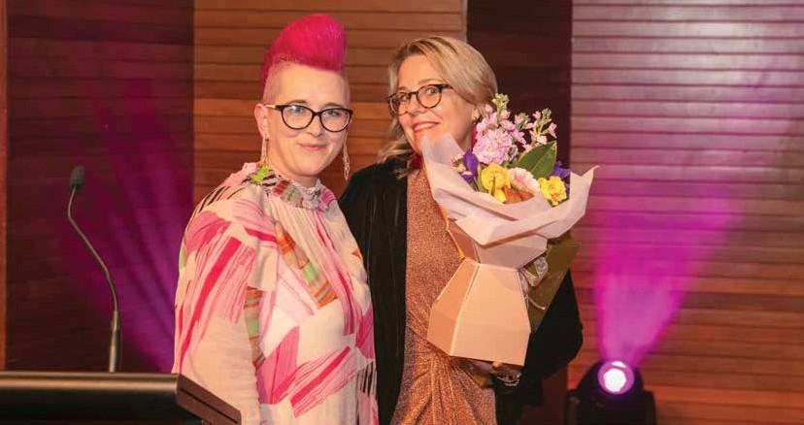Farewell and thanks to departing CEO

Whether you knew or know her as ’Scottish Pink’, Maverick or Michelle, you cannot forget Michelle Berriman. After a tough four years at the helm of FINZ, Michelle finished at the end of October.

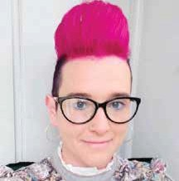

Michelle inherited FINZ at a time of upheaval. Former long-time CEO James Austin had departed and two subsequent appointees to the role were unexpectedly short-term. It was her energy and enthusiasm that had Co- chairs Shane Chisholm and Alice Montague appoint Michelle in 2018.
FINZ had been through some tough financial experience and it was expected that appointment of Michelle would change the
Institute’s fortunes. She set about to enliven the Institute and bring about a new level of activity and energy.
In her first few months, Michelle had commissioned a Member survey, refreshed the magazine and organised a digital speaking tour.
Her second year saw Michelle organise a ‘state of the nation’ tour with Scott Lockie, a speaking tour with Stephen George, a Corporate Partnership tour with Abby Clements and “Unicorns Unite” events with Vu le. Michelle then ran her first FINZ conference. With her background in events fundraising, a Michelle conference was never going to be run-of-the-mill.
Michelle also relaunched the

Mentor programme and embarked on the first of her advocacy and lobbying work, submitting on proposed Third Party fundraising changes, Class 3 gambling rules changes and swinging into action when Kiwibank was the first to announce the imminent demise of cheques. And then COVID struck!
2020 was a near crippling year. Michelle moved to provide support to small and struggling
charities by introducing free 1-year subscriptions to new charities, micro-memberships for small charities and a broad range of
on-line learning opportunities. The planned conference was held, but with very limited actual attendance and most sessions
conducted on-line, using hologram technology to bring some attraction to both speakers and attendees.
The demise of cheques project consumed significant time and energy but was concluded with better outcomes than had been predicted. However, the financial
impact of COVID nearly drove FINZ into the ground. If not for a special appeal being launched (raising $40,000 from Members and international supporters), FINZ would have likely folded.
We all expected COVID to blow over by 2021 but, it didn’t. It was another tough year, survived only thanks to the 2020 special appeal campaign. The financial pain continued when the March conference had to be postponed
until September and then ultimately abandoned. Meantime, Michelle led further significant projects including cheque advocacy and lobbying, research into gifts in wills and initial work on bullying and harassment within the sector.
The 2021 conference had been postponed to March 2022 and then a third time due to ongoing COVID restrictions. During 2022, Michelle facilitated a refresh of the Constitution and Codes of Ethics and Professional Conduct, actively participated in the newly formed
Charities Sector User Group and facilitated submissions on XRB reporting standards, responses to DIA Policy consultation topics, successfully lobbied the Finance
and Expenditure Select Committee to allow Class 3 lotteries to be promoted and transacted on-
line and finally orchestrated the construction of a submission on the Charities Amendment Bill. The conference was eventually held
in August 2022. It was a huge success, attended by a record number of delegates. Although not planned that way, the conference became Michelle’s finale. And what a way to go! Those four years were tough but the achievements under the circumstances were outstanding.
Michelle and her family have relocated to Melbourne and we expect to and look forward to continuing to see Michelle as she continues working within the sector.

Suppliers of ‘PIE’ (Postage Included Envelopes)
GET YOUR ORDER IN TODAY!

For FINZ Member discounts with ROE PRINT contact:
Grant Chellew
021 362 068
grant@chellew.co.nz

Peter Clarke
021 224 5058
peter@roeprintservices.co.nz

Kylie Malin
027 420 5337
kylie@roeprintservices.co.nz

Create clarity for your charity by leaning into change
By Anusha Bhana, Digital & Comms Co-Lead for TFNNZ

Change is inevitable and even more so in the face of a global pandemic. In the last 3 years, online events and meetings have become the norm, remote working has become essential and widely accepted, and charities that once solely relied on in-person fundraising have been compelled to add online fundraising to their kete of skills.

The Funding Network NZ (TFNNZ) is an affiliate of The Funding Network, founded back in 2002 in the UK by Canadian art dealer and philanthropist, Frederick Mulder CBE. The idea was to create a live giving circle aka ‘live crowdfunding’ which
offered small, grassroots charities working for social change the opportunity to ‘pitch’ for funds from an audience of potential donors.
The New Zealand version of The Funding Network was founded in 2014 by Nick Edgar, and took its cue from the UK model. For five years TFNNZ hosted successful live crowdfunding events mostly
in Auckland, where budding philanthropists and corporate
match-funders listened to pitches by charities and pledged their support.
On November 25th 2019, an in- person event at GridAKL in Tāmaki Makaurau Auckland took place where generous Kiwis pledged $20k in support of three charities. Little did we know at the time, but this was to be our last in-person event.
over as CEO, and within a month the COVID-19 global pandemic had sent Aotearoa New Zealand (and the world) into lockdown.
With in-person gatherings out of the question, we searched for ways we could still support Kiwi grassroots charities, while also staying safe. Within three
weeks, we’d connected with three charitable foundations and three charities working on the frontline and set-up what was to be the first of five #HelpFromHome events.
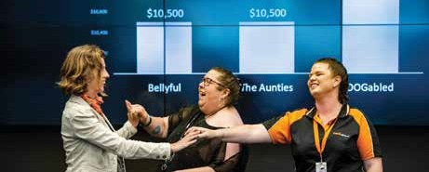
#HelpFromHome was designed to enable generous Kiwis to contribute to grassroots charities from the comfort of their ‘bubbles’. Each #HelpFromHome was a 45
minute Facebook Live event with three charity pitches, and then a call to action to viewers to make donations through Givealittle. The first online event raised over $60k and cost us a one-month Zoom webinar subscription. As time went on we added some training in presentation skills and basic crowdfunding, and the 5 events raised $280,351 overall!
In November 2021, nearly two years into the pandemic,
multiple lockdowns, and continued restrictions on in-person events,
it was time for another change. We were being approached by a large number of small, grassroots charities who wanted a place in

In February 2020, Tim Pare took
TFN Live Crowdfunding event 2018

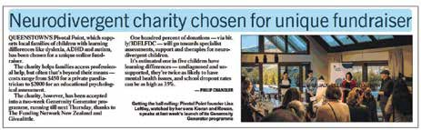

A piece of media coverage from one of our GG charities’ campaigns
FINZ Excellence in Innovation award win.

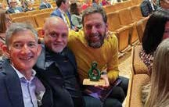
#HelpFromHome (we could only take 3 per event), and had identified a significant knowledge gap in the small charity sector.
Small charities wanted, and really needed, to learn the essentials of online fundraising, so they could respond to increased community needs caused by the pandemic.
And so we created and piloted the Generosity Generator (GG) in early 2022 - an online fundraising training programme specifically designed for small Kiwi grassroots charities. The programme teaches the essentials of how to create, promote and run a successful crowdfunding campaign, and
then provides an opportunity to put these skills into practice and raise some funds through a two- week crowdfunding campaign on Givealittle.
It’s a worthwhile investment of time for small charities who want to diversify their funding streams and grow their giving community. The training is also delivered completely online via Zoom, so small charities from anywhere in New Zealand can participate.
We ran the programme twice in 2022, once in March/April and once in Aug/Sept, trained 64 small Kiwi
charities and supported them to raise a collective total of $455,298. GG enabled these charities to raise critical funds and embedded fundraising knowledge through practical application to help them build a solid foundation for a more
financially sustainable future. In July 2022, we were stoked to win the 2022 FINZ Excellence in Innovation award at the FINZ Conference, for the pilot Generosity Generator.
The Generosity Generator was a significant change for us, but a worthwhile one. It helped us see
where and how we could best build the capacity of small charities, while also inspiring generosity. The small charity sector has always and will always be the focus of our mahi. We are proud to share that since our inception in 2014, we’ve supported 107 small charities to raise a total of over $1.1 million.
Change is inevitable, but it’s also unpredictable. You don’t know exactly when or what will prompt you to make a change, but being open to it is key. The changes to The Funding Network NZ since the pandemic have created clarity and amplified our purpose as a charity
- and in hindsight, it’s just what we needed!
From Left to Right: Nick Edgar, Trustee and TFNNZ Founder, Paul Dennis, Trustee and Tim Pare, Charities & Partnerships Co-Lead.
Learn more about us here: www. thefundingnetwork.org.nz, sign up to our mailing list and follow us on Facebook, Instagram and LinkedIn for the latest news.

Anusha Bhana is a self-employed, qualified and experienced communications, events and digital marketing professional, trading as Korimako Creative. She is originally from Tāmaki Makaurau and is now based in Whitianga.
Her compassionate, empathetic nature and strong drive to
use authentic and ethical communication for social change and advocacy has led her to work with organisations such as Inner City Women’s Group, Creative Coromandel, Business Link Pacific/ Ministry of Foreign Affairs & Trade, Digital Equity Coalition Aotearoa, Community Think and Inclusive Aotearoa Collective Tāhono. She
is skilled at communicating with a diverse range of audiences using on trend digital tools, and offers
a refreshing mix of big picture strategic thinking, attention to detail and creativity to help for-purpose organisations and projects grow and thrive.
She currently provides communications, events and digital marketing expertise to Kākano Youth Arts Collective, Tea Leaf Trust (Sri Lanka), The Funding Network NZ and the University of Central Asia (Kyrgyzstan).

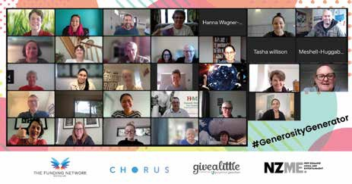

Generosity Generator Aug/Sept training workshop

The sector is growing up

The community and voluntary sector is how many communities have been established, supported, protected and developed over centuries in many cultures. Sometimes it has been harnessed into formal networks and systems, such as through the power and influence of faith-based organisations. And sometimes it has been harnessed through selective groupings of people, such as through Guilds or closed communities.

The shape, form and influence of the sector has constantly changed, although the core tenets have generally remained stable.
In Western societies, the influence of the sector has waxed and waned between times of centralisation under various government or societal regimes and dictates – socialism, and communism being significant examples – and decentralisation.
The sector in New Zealand was always strong within the immigrant population as the nation established itself, being driven by principles
of comparative egalitarianism, although the social reforms of the late 1800s and early 1900s
reduced the need for community- based social support services as state-based social policies were introduced at that time.
It has been the post WWII era where the sector has emerged as an essential component of
community and national well-being
– the third leg of the milking stool that balances society between state control (through public service)
and capitalism (through private enterprise).
One of the necessities of a healthy community and voluntary sector is the availability of funding, whether that be through grants, contracts, sponsorships or philanthropy. It is through the
endeavours of charities in particular, to better enunciate their purpose and demonstrate ability to make change and achieve desired outcomes that we have been able to see growth and maturation of the sector in Aotearoa New Zealand.
The advent of the Charities database has provided visibility of the sector and levels of support that were hitherto not known. The establishment of the database was timely. From a fundraising perspective, it has provided an indication of the maturing of fundraising practice and response as the table below demonstrates.
Interestingly. Only between two- thirds and less than three-quarters of all registered charities engage in fundraising activity. The proportion is slowly increasing, but at a lower rate than one would predict for the sector.
It is otherwise staggering to observe the level of fundraising success achieved by charities over the past decade. Total fundraising revenue by registered charities has grown more than
3-fold (closer to 4-fold) in the past twelve years! If ever there was a measure of community
endorsement and confidence in the voluntary and community sector, this is it! And that makes a mockery of the argument for changes
being proposed in the Charities Amendment Bill.
What is perhaps a little more interesting however, is the level of median fundraising revenue. Back in 2010, 50% of charities reported receiving less than $24,233 in annual fundraising revenue (and

50% receiving more than that amount). That has climbed to 50% receiving less (and 50% more) than
Year | Number of Fundraising Charities | Proportion of charities fundraising  >$1000 | Total fundraising revenue $bn | Average fundraising revenue $000 | Median $
2010 | 9,527 | 66% | 1.733 | 182 | 24,223
2011 | 10,632 | 67% | 2.097 | 197 | 23,439
2012 | 11,281 | 67% | 2.111 | 187 | 23,875
2013 | 12,067 | 68% | 2.144 | 178 | 23,595
2014 | 12,571 | 67% | 2.361 | 188 | 24,266
2015 | 13,173 | 68% | 2.470 | 188 | 24,875
2016 | 14,380 | 71% | 3.459 | 241 | 28,388
2017 | 15,567 | 74% | 4.597 | 295 | 31,141
2018 | 15,870 | 74% | 5.233 | 330 | 32,844
2019 | 16,373 | 73% | 5.520 | 337 | 34,549
2020 | 16,935 | 73% | 6.029 | 356 | 33,852
2021 | 16,927 | 72% | 6.736 | 398 | 32,595
2022 | 15,638 | 71% | 6.559 | 419 | 34,275

$34,275 by 2022. That represents
a lift of only 40% above 2010 levels. That sends a clear signal that community support through fundraising contribution favours the larger charities. They appear to be the ones in whom the wide community has most trust.
Obviously it is the larger, more established charities most likely to employ fundraising professionals – being those individuals and
organisations who publicly declare compliance with and adherence to fundraising codes of ethics and professional conduct.
If ever a charity needs evidence of the value of belonging to and publicly confirming and committing to membership of the Fundraising Institute of New Zealand, this has to
be it.

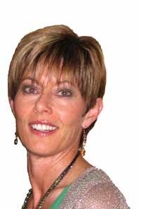
FINZ
Mentor Programme

“In learning, you will teach, and in teaching, you will learn” – Phil Collins

Available only to FINZ members, the Mentor Programme matches those seeking guidance in bequests, capital campaigns, leadership, governance and much more, with one of our 19 experienced fundraising leaders. Over approximately four months the pairs plan, meet, and reflect on career goals and strategies for their time together. Our mentors make a commitment to their mentee’s future, offering up their time, energy and extensive knowledge. Our mentees
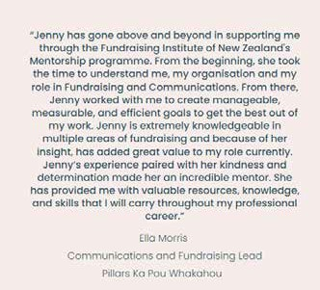make a commitment to their professional development and the . In a great mentorship, mentees get the benefits of learning from someone who’s been there before, and
mentors get the reward of paying it forward.
In June 2022, FINZ
paired a cohort of 15 professional fundraisers with an expert mentor through our Programme. Here, our programme participants Jenny Caston (Director, Willpower),
and Ella Morris
(Communications & FR Lead, Pillars Ka Pou Whakahou) share their experience:
Jenny - It’s a privilege to be a Mentor – to invest in and add
value to flourishing fundraisers. I’m passionate about life long learning and helping others to reach their potential so I thoroughly enjoyed participating in the 2022 FINZ Mentor programme. It was well structured and paced, adequately resourced, collaborative and provided a supportive learning context for both Mentor and
Mentee building competency, confidence and capabilities.
My Mentee was a pleasure to work with and maximised our time together to grow, develop and put into practice applicable learnings.
I am delighted to be a member of FINZ and a Mentor. I facilitate the Auckland Gifts in Wills Special Interest Group which meets quarterly to share learning, experience and expertise. It’s highly valued as a supportive network and warmly welcomes new participants.

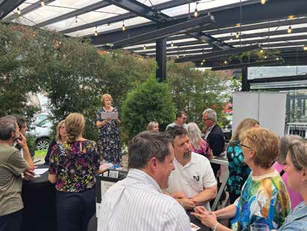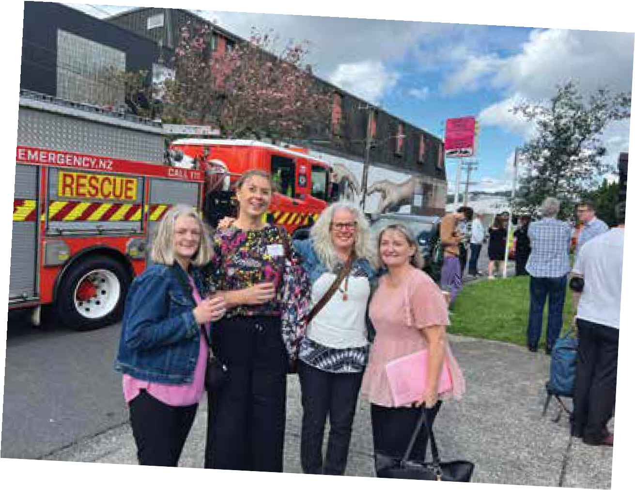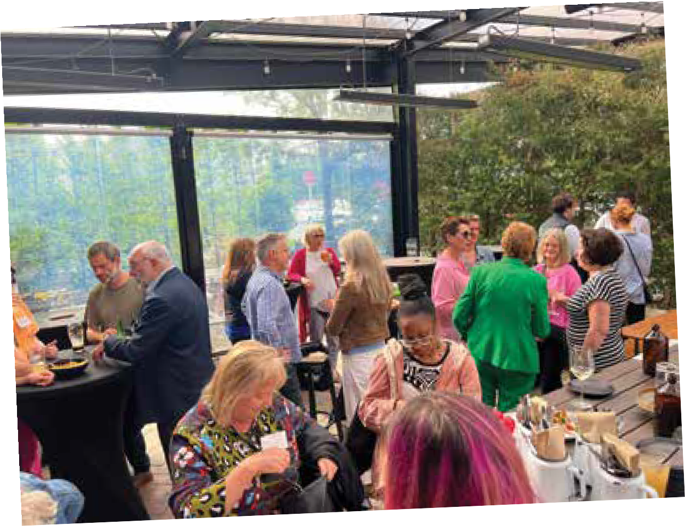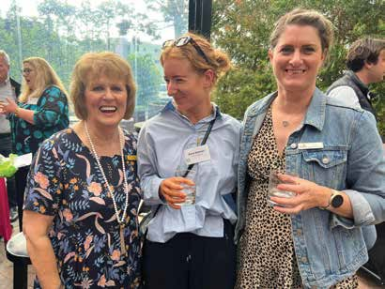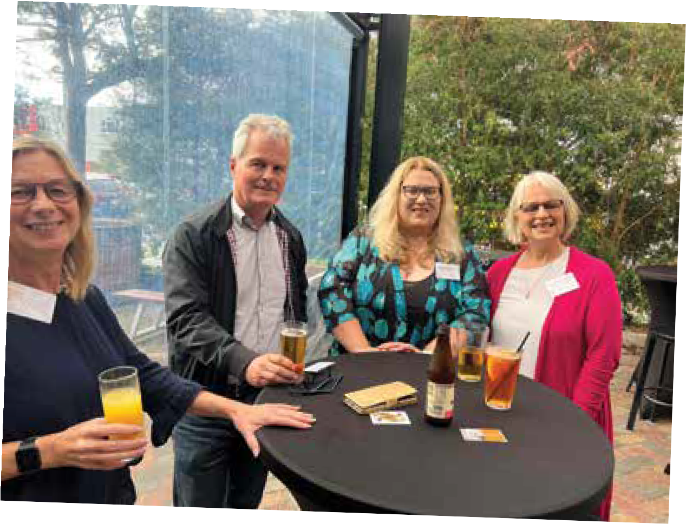Northern EOY Function

roe print services
PROUD PRINT SPONSORS OF FINZ MAGAZINE

